**Requirements Document**

**Golars Billing Software**

**For**

**BY**

**Golars Networks**

**Hyderabad, India**

Contents

**1.** **Purpose** 2

**2.** **Revision History** 2

**3.** **Project Description** 3

**4.** **Users** 3

***4.1.*** ***Admin:*** 3

***4.2.*** ***Student*** 5

***4.3.*** ***Faculty*** 6

***4.4.*** ***Consultancy*** 6

***4.5.*** ***Common*** 7

**5.** **Project Estimation** 7

**6.** **Technology Stack** 7

**7.** **Mock Up Screens** 8

1. **Purpose**

This document specifies the functional requirements of GOLARS BILLING SOFTWARE for GOLARS NETWORKS. This document serves as base for Architects/developers in designing and development of the application. Testers will use this document to write / execute the test cases and to validate the test results.

This will be revised after the detailed requirement gathering sessions. This document will be updated with new requirements or changed requirements only after getting proper approvals from client (GOLARS Networks) and Project team.

1. **Revision History**

|  |  |  |
| --- | --- | --- |
| **Version** | **Updated By** | **Comments** |
| 0.1 | C. Ashwin Kumar & D. Satish | Draft |
|  |  |  |
|  |  |  |

1. **Project Description**

Golars Billing Software is a web based portal that will used by Golars networks used to create projects, create employee’s, maintain total project details, and Generate PDF of entire documents as a single PDF Binder Etc... This software also helps the project manager to have a complete awareness of every employee task.

1. **Users**
   1. ***Project Manager:***

**Project manager creates the Employees and Add projects.**

***Login:*** Project Manager can login into the Application using user id and password. Requirements for Password are listed below.

***Recover password:*** Project Manager can recover password by clicking forgot password. Reset Password link will be sent to Project Manager Email.

Project Manager should create Employee

*Employee ID \**

*First name \**

*Last Name \**

*Password * Send reset link*

*Address*

*Phone \**

*Email \**

*Alternate Email id*

***Add Project:*** Project Manager can create project.To create a project Project Manager needs to supply following information.

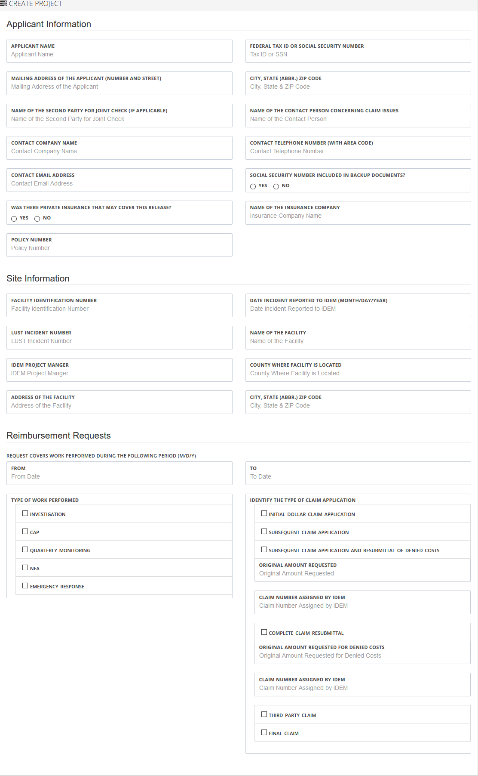

***Applicant Information:***

*Applicant Name*

*Federal Tax ID or Social Security Number*

*Mailing Address of the Applicant (number and street)*

*City, State (Abbr.) ZIP Code*

*Name of the Second Party for Joint Check (if applicable)*

*Name of the Contact Person Concerning Claim Issues*

*Contact Company Name*

*Contact Telephone Number (with area code)*

*Contact Email Address*

*Social Security Number Included in Backup Documents? (Y/N)*

*Was There Private Insurance That May Cover This Release? (Y/N)*

*Name of the Insurance Company*

*Policy Number*

***Applicant Information:***

*Facility Identification Number*

*Date Incident Reported to IDEM (month/day/year)*

*LUST Incident Number*

*Name of the Facility*

*IDEM Project Manger*

*County Where Facility is Located*

*Address of the Facility*

*City, State (Abbr.) ZIP Code*

***Reimbursement Requests:***

*Request covers work performed during the following period (m/d/y)*

* *From Date*
* *To Date*

*Type of work performed*

* *Investigation*
* *CAP*
* *Quarterly Monitoring*
* *NFA*
* *Emergency Response*

*Identify the type of claim application*

* *Initial dollar claim application*
* *Subsequent claim application*
* *Subsequent claim application and Resubmittal of denied costs*
* *Original Amount Requested*
* *Claim Number Assigned by IDEM*
* *Complete Claim Resubmittal*
* *Original Amount Requested for Denied Costs*
* *Claim Number Assigned by IDEM*
* *Third Party Claim*
* *Final Claim*

***Projects List:*** Shows the list of all projects.

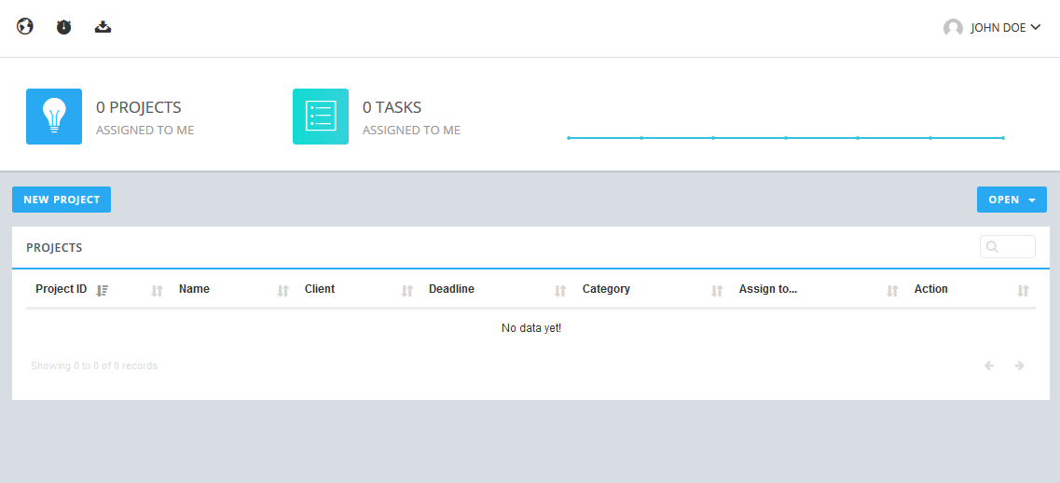

***Project Details:*** Shows the details of particular project.

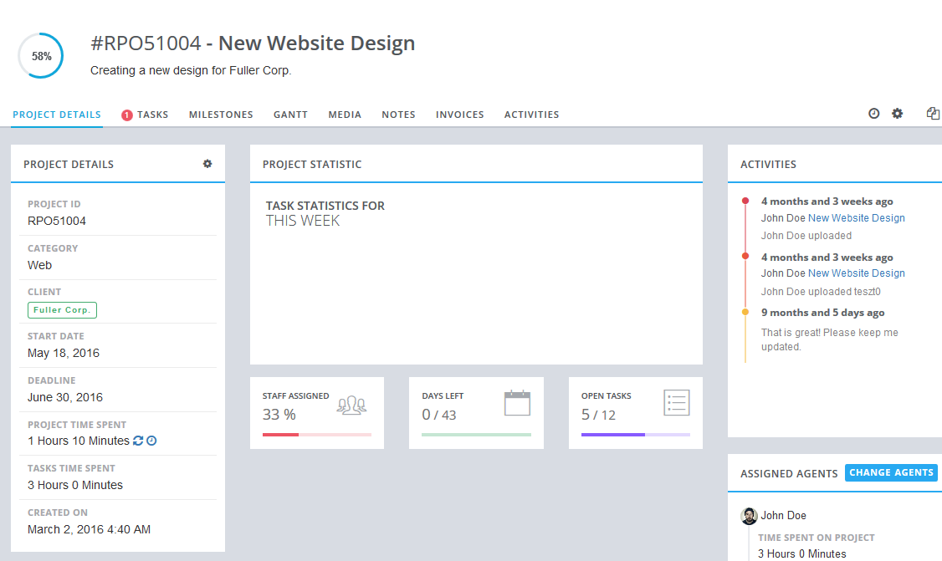

1. **Technology Stack**

List of technologies used for this project are as follows.

|  |  |
| --- | --- |
| **Framework/Tools** | **Description** |
| Spring -MVC/JSP | UI Development |
| Spring - IOC & AOP | Middle Layer |
| Hibernate | Persistence Layer |
| MySQL/Postgres | Database |
| Tomcat | Server |
| Jenkins - Build & Deploy tool | Build & deploy tool |
| Jira & Confluence - Quality & Project Management | Quality, Project Management |
| SVN/CVS | Code maintenance |

1. **Mock Up Screens**

Mock Up screens will provide in this section. This section will be updated after the completion of UI design phase.

**My New Additions**

* Multiple Faculties to one batch
* Please add this functionality. At least for 3 faculties.
* Possibly adding an audio upload. Also video upload
* Questions and Answers after every class, so that students can go and answer them. and we will get email once answered
* Reports Section
* Mock up website
* POWERPOINT TEMPLATE
* PAMPLET
* LOGO DESIGN

**Support Manual – Like how to add new item in dropdown – Very Important**

**Reports**

* **Should be able to send attendance reports**
* **Should be able to send Assignment reports**
* **Should be able to send list of students reports**
* **Should be able to send List of consultancies**
* **Should be able to send list of faculties**
* **Should be able to send list of students per batch giving an option for year**

**Agreement and terms and conditions**

Moving from batch to batch – We need comment

Global - Search Criteria – and using search criteria

Simple search is included - - No need of Global search - Confirmed.

**Appendix A**

IT Solutions

Servesys Inc

eminenceitsol

Horizoncs

genesisitinc

intonenetworks

centraprise

RM Networks

Teradyne Infotech Inc.

Javelin Technologies

VLS IT Consulting

Still adding more

**Appendix B**

* [SAP](http://techjobs.sulekha.com/sap_classroom-online-training-course-usa)  (321)
* [Oracle](http://techjobs.sulekha.com/oracle_classroom-online-training-course-usa)  (122)
* [J2EE](http://techjobs.sulekha.com/j2ee_classroom-online-training-course-usa)  (121)
* [Java](http://techjobs.sulekha.com/java_classroom-online-training-course-usa)  (121)
* [Java/J2EE](http://techjobs.sulekha.com/java-j2ee_classroom-online-training-course-usa)  (121)
* [QA](http://techjobs.sulekha.com/qa_classroom-online-training-course-usa)  (120)
* [Business Analyst](http://techjobs.sulekha.com/business-analyst_classroom-online-training-course-usa)  (120)
* [.Net](http://techjobs.sulekha.com/net_classroom-online-training-course-usa)  (104)
* [.Net/ASP/VB/C Sharp](http://techjobs.sulekha.com/net-asp-vb-c-sharp_classroom-online-training-course-usa)  (104)
* [ASP](http://techjobs.sulekha.com/asp_classroom-online-training-course-usa)  (104)
* [C Sharp](http://techjobs.sulekha.com/c-sharp_classroom-online-training-course-usa)  (104)
* [VB](http://techjobs.sulekha.com/vb_classroom-online-training-course-usa)  (104)
* [BI](http://techjobs.sulekha.com/bi_classroom-online-training-course-usa)  (79)
* [DW](http://techjobs.sulekha.com/dw_classroom-online-training-course-usa)  (79)
* [DW/BI](http://techjobs.sulekha.com/dw-bi_classroom-online-training-course-usa)  (79)
* [Informatica](http://techjobs.sulekha.com/informatica_classroom-online-training-course-usa)  (74)
* [Sharepoint](http://techjobs.sulekha.com/sharepoint_classroom-online-training-course-usa)  (60)
* [Cognos](http://techjobs.sulekha.com/cognos_classroom-online-training-course-usa)  (57)
* [DataStage](http://techjobs.sulekha.com/datastage_classroom-online-training-course-usa)  (56)
* [SQL Servers](http://techjobs.sulekha.com/sql-servers_classroom-online-training-course-usa)  (52)
* [SAS](http://techjobs.sulekha.com/sas_classroom-online-training-course-usa)  (50)
* [SQL DBA](http://techjobs.sulekha.com/sql-dba_classroom-online-training-course-usa)  (48)
* [Oracle DBA](http://techjobs.sulekha.com/oracle-dba_classroom-online-training-course-usa)  (48)
* [Salesforce](http://techjobs.sulekha.com/salesforce_classroom-online-training-course-usa)  (45)
* [PMP](http://techjobs.sulekha.com/pmp_classroom-online-training-course-usa)  (42)
* [Project Management](http://techjobs.sulekha.com/project-management_classroom-online-training-course-usa)  (42)
* [Project Management/PMP](http://techjobs.sulekha.com/project-management-pmp_classroom-online-training-course-usa)  (42)
* [Peoplesoft](http://techjobs.sulekha.com/peoplesoft_classroom-online-training-course-usa)  (41)
* [Business Objects](http://techjobs.sulekha.com/business-objects_classroom-online-training-course-usa)  (41)
* [Linux](http://techjobs.sulekha.com/linux_classroom-online-training-course-usa)  (40)
* [Linux/Unix](http://techjobs.sulekha.com/linux-unix_classroom-online-training-course-usa)  (40)
* [Unix](http://techjobs.sulekha.com/unix_classroom-online-training-course-usa)  (40)
* [SQL & Related](http://techjobs.sulekha.com/sql-related_classroom-online-training-course-usa)  (40)
* [Hyperion](http://techjobs.sulekha.com/hyperion_classroom-online-training-course-usa)  (39)
* [TIBCO](http://techjobs.sulekha.com/tibco_classroom-online-training-course-usa)  (38)
* [TIBCO/Webmethods](http://techjobs.sulekha.com/tibco-webmethods_classroom-online-training-course-usa)  (38)
* [Webmethods](http://techjobs.sulekha.com/webmethods_classroom-online-training-course-usa)  (38)
* [Oracle OLAP](http://techjobs.sulekha.com/oracle-olap_classroom-online-training-course-usa)  (36)
* [CCNA](http://techjobs.sulekha.com/ccna_classroom-online-training-course-usa)  (33)
* [Teradata Database DBA](http://techjobs.sulekha.com/teradata-database-dba_classroom-online-training-course-usa)  (31)
* [Microstrategy](http://techjobs.sulekha.com/microstrategy_classroom-online-training-course-usa)  (30)
* [Crystal Reports](http://techjobs.sulekha.com/crystal-reports_classroom-online-training-course-usa)  (29)
* [Siebel](http://techjobs.sulekha.com/siebel_classroom-online-training-course-usa)  (29)
* [Microsoft Technologies](http://techjobs.sulekha.com/microsoft-technologies_classroom-online-training-course-usa)  (28)
* [SQL BI](http://techjobs.sulekha.com/sql-bi_classroom-online-training-course-usa)  (27)
* [Adobe Flex](http://techjobs.sulekha.com/adobe-flex_classroom-online-training-course-usa)  (26)
* [Android](http://techjobs.sulekha.com/android_classroom-online-training-course-usa)  (24)
* [Websphere Admin](http://techjobs.sulekha.com/websphere-admin_classroom-online-training-course-usa)  (20)
* [Networking](http://techjobs.sulekha.com/networking_classroom-online-training-course-usa)  (20)
* [QTP](http://techjobs.sulekha.com/qtp_classroom-online-training-course-usa)  (20)
* [Ab Initio](http://techjobs.sulekha.com/ab-initio_classroom-online-training-course-usa)  (19)
* [Database Administration](http://techjobs.sulekha.com/database-administration_classroom-online-training-course-usa)  (18)
* [Pega](http://techjobs.sulekha.com/pega_classroom-online-training-course-usa)  (17)
* [CCNP](http://techjobs.sulekha.com/ccnp_classroom-online-training-course-usa)  (16)
* [Data Modeling](http://techjobs.sulekha.com/data-modeling_classroom-online-training-course-usa)  (16)
* [iPhone Applications](http://techjobs.sulekha.com/iphone-applications_classroom-online-training-course-usa)  (15)
* [IBM Maximo](http://techjobs.sulekha.com/ibm-maximo_classroom-online-training-course-usa)  (14)
* [Server Administration](http://techjobs.sulekha.com/server-administration_classroom-online-training-course-usa)  (12)
* [BizTalk](http://techjobs.sulekha.com/biztalk_classroom-online-training-course-usa)  (12)
* [Systems Administration](http://techjobs.sulekha.com/systems-administration_classroom-online-training-course-usa)  (12)
* [VMware](http://techjobs.sulekha.com/vmware_classroom-online-training-course-usa)  (12)
* [Storage Area Networks](http://techjobs.sulekha.com/storage-area-networks_classroom-online-training-course-usa)  (12)
* [Cloud Computing](http://techjobs.sulekha.com/cloud-computing_classroom-online-training-course-usa)  (12)
* [Qlikview](http://techjobs.sulekha.com/qlikview_classroom-online-training-course-usa)  (12)
* [Hadoop](http://techjobs.sulekha.com/hadoop_classroom-online-training-course-usa)  (11)
* [Hibernate ORM](http://techjobs.sulekha.com/hibernate-orm_classroom-online-training-course-usa)  (10)
* [Adobe](http://techjobs.sulekha.com/adobe_classroom-online-training-course-usa)  (10)
* [Spring Framework](http://techjobs.sulekha.com/spring-framework_classroom-online-training-course-usa)  (10)
* [Microsoft Dynamics](http://techjobs.sulekha.com/microsoft-dynamics_classroom-online-training-course-usa)  (10)
* [MY SQL](http://techjobs.sulekha.com/my-sql_classroom-online-training-course-usa)  (10)
* [CRM](http://techjobs.sulekha.com/crm_classroom-online-training-course-usa)  (10)
* [C Plus Plus](http://techjobs.sulekha.com/c-plus-plus_classroom-online-training-course-usa)  (9)
* [Ruby on Rails](http://techjobs.sulekha.com/ruby-on-rails_classroom-online-training-course-usa)  (9)
* [WebLogic Admin](http://techjobs.sulekha.com/weblogic-admin_classroom-online-training-course-usa)  (9)
* [SOA and BPEL](http://techjobs.sulekha.com/soa-and-bpel_classroom-online-training-course-usa)  (8)
* [Ecommerce](http://techjobs.sulekha.com/ecommerce_classroom-online-training-course-usa)  (8)
* [HealthCare](http://techjobs.sulekha.com/healthcare_classroom-online-training-course-usa)  (8)
* [Servers](http://techjobs.sulekha.com/servers_classroom-online-training-course-usa)  (7)
* [Clinical Research](http://techjobs.sulekha.com/clinical-research_classroom-online-training-course-usa)  (6)
* [Selenium](http://techjobs.sulekha.com/selenium_classroom-online-training-course-usa)  (6)
* [Business Process Management(BPM)](http://techjobs.sulekha.com/business-process-management-bpm_classroom-online-training-course-usa) (5)
* [Red hat Linux](http://techjobs.sulekha.com/red-hat-linux_classroom-online-training-course-usa)  (4)
* [Rational Testing](http://techjobs.sulekha.com/rational-testing_classroom-online-training-course-usa)  (4)
* [Spring MVC](http://techjobs.sulekha.com/spring-mvc_classroom-online-training-course-usa)  (4)
* [Six Sigma](http://techjobs.sulekha.com/six-sigma_classroom-online-training-course-usa)  (4)
* [Big Data Training Technology](http://techjobs.sulekha.com/big-data-training-technology_classroom-online-training-course-usa)  (4)
* [SoapUI](http://techjobs.sulekha.com/soapui_classroom-online-training-course-usa)  (3)
* [Portal Server](http://techjobs.sulekha.com/portal-server_classroom-online-training-course-usa)  (3)
* [Scripting(CGI)](http://techjobs.sulekha.com/scripting-cgi_classroom-online-training-course-usa)  (3)
* [Scripting(PERL)](http://techjobs.sulekha.com/scripting-perl_classroom-online-training-course-usa)  (3)
* [Scripting(PERL)/Scripting(CGI)](http://techjobs.sulekha.com/scripting-perl-scripting-cgi_classroom-online-training-course-usa)  (3)
* [Agile Techniques](http://techjobs.sulekha.com/agile-techniques_classroom-online-training-course-usa)  (3)
* [Tibco Iprocess](http://techjobs.sulekha.com/tibco-iprocess_classroom-online-training-course-usa)  (2)
* [Actuate](http://techjobs.sulekha.com/actuate_classroom-online-training-course-usa)  (2)
* [Virtualisation](http://techjobs.sulekha.com/virtualisation_classroom-online-training-course-usa)  (2)
* [MQ Series](http://techjobs.sulekha.com/mq-series_classroom-online-training-course-usa)  (2)
* [Multimedia](http://techjobs.sulekha.com/multimedia_classroom-online-training-course-usa)  (2)
* [Configuration & Release](http://techjobs.sulekha.com/configuration-release_classroom-online-training-course-usa)  (2)
* [Documentum](http://techjobs.sulekha.com/documentum_classroom-online-training-course-usa)  (2)
* [MS Office](http://techjobs.sulekha.com/ms-office_classroom-online-training-course-usa)  (2)
* [SeeBeyond](http://techjobs.sulekha.com/seebeyond_classroom-online-training-course-usa)  (1)
* [Embedded Systems](http://techjobs.sulekha.com/embedded-systems_classroom-online-training-course-usa)  (1)
* [Sun Identity Management](http://techjobs.sulekha.com/sun-identity-management_classroom-online-training-course-usa)  (1)
* [Dashboards](http://techjobs.sulekha.com/dashboards_classroom-online-training-course-usa)  (1)
* [ColdFusion](http://techjobs.sulekha.com/coldfusion_classroom-online-training-course-usa)  (1)
* [Telecom](http://techjobs.sulekha.com/telecom_classroom-online-training-course-usa)  (1)
* [Telecom/Wireless](http://techjobs.sulekha.com/telecom-wireless_classroom-online-training-course-usa)  (1)
* [Wireless](http://techjobs.sulekha.com/wireless_classroom-online-training-course-usa)  (1)
* [VLSI Design](http://techjobs.sulekha.com/vlsi-design_classroom-online-training-course-usa)  (1)
* [ASIC Design](http://techjobs.sulekha.com/asic-design_classroom-online-training-course-usa)  (1)
* [Content Management System](http://techjobs.sulekha.com/content-management-system_classroom-online-training-course-usa)  (1)
* [RFID](http://techjobs.sulekha.com/rfid_classroom-online-training-course-usa)
* [BIT Reports](http://techjobs.sulekha.com/bit-reports_classroom-online-training-course-usa)
* [Rational Application Developer](http://techjobs.sulekha.com/rational-application-developer_classroom-online-training-course-usa)
* [Lotus Forms](http://techjobs.sulekha.com/lotus-forms_classroom-online-training-course-usa)
* [Lotus Notes & Domino](http://techjobs.sulekha.com/lotus-notes-domino_classroom-online-training-course-usa)
* [Tuxedo](http://techjobs.sulekha.com/tuxedo_classroom-online-training-course-usa)
* [FISA](http://techjobs.sulekha.com/fisa_classroom-online-training-course-usa)
* [AutoCAD](http://techjobs.sulekha.com/autocad_classroom-online-training-course-usa)
* [Datacom](http://techjobs.sulekha.com/datacom_classroom-online-training-course-usa)
* [BREW](http://techjobs.sulekha.com/brew_classroom-online-training-course-usa)
* [Mobile Applications](http://techjobs.sulekha.com/mobile-applications_classroom-online-training-course-usa)
* [ADF](http://techjobs.sulekha.com/adf_classroom-online-training-course-usa)
* [Sql](http://techjobs.sulekha.com/sql_classroom-online-training-course-usa)
* [Demantra](http://techjobs.sulekha.com/demantra_classroom-online-training-course-usa)
* [See Beyond](http://techjobs.sulekha.com/see-beyond_classroom-online-training-course-usa)
* [Database](http://techjobs.sulekha.com/database_classroom-online-training-course-usa)
* [Business Intelligence](http://techjobs.sulekha.com/business-intelligence_classroom-online-training-course-usa)
* [Web / Internet / Multimedia](http://techjobs.sulekha.com/web-internet-multimedia_classroom-online-training-course-usa)
* [Network Administration](http://techjobs.sulekha.com/network-administration_classroom-online-training-course-usa)
* [Engineering](http://techjobs.sulekha.com/engineering_classroom-online-training-course-usa)
* [Programming](http://techjobs.sulekha.com/programming_classroom-online-training-course-usa)
* [Software Testing](http://techjobs.sulekha.com/software-testing_classroom-online-training-course-usa)
* [Content Management](http://techjobs.sulekha.com/content-management_classroom-online-training-course-usa)
* [Others](http://techjobs.sulekha.com/others_classroom-online-training-course-usa)
* [Object Relational Mapping](http://techjobs.sulekha.com/object-relational-mapping_classroom-online-training-course-usa)
* [Server](http://techjobs.sulekha.com/server_classroom-online-training-course-usa)
* [System and Network Administration](http://techjobs.sulekha.com/system-and-network-administration_classroom-online-training-course-usa)
* [Network](http://techjobs.sulekha.com/network_classroom-online-training-course-usa)
* [Software Development](http://techjobs.sulekha.com/software-development_classroom-online-training-course-usa)
* [Mobile Development](http://techjobs.sulekha.com/mobile-development_classroom-online-training-course-usa)
* [Reporting](http://techjobs.sulekha.com/reporting_classroom-online-training-course-usa)
* [ERP](http://techjobs.sulekha.com/erp_classroom-online-training-course-usa)
* [Vignette](http://techjobs.sulekha.com/vignette_classroom-online-training-course-usa)
* [Brokerage & Messaging](http://techjobs.sulekha.com/brokerage-messaging_classroom-online-training-course-usa)
* [Remedy](http://techjobs.sulekha.com/remedy_classroom-online-training-course-usa)
* [Visio](http://techjobs.sulekha.com/visio_classroom-online-training-course-usa)
* [AIX Admin](http://techjobs.sulekha.com/aix-admin_classroom-online-training-course-usa)
* [IT - Software](http://techjobs.sulekha.com/it-software_classroom-online-training-course-usa)