

CLIENT PROJECT REPORT.

Version 1.0

GOLARS NETWORKS PVT LTD.

#170/67,171, BALAJI EMPIRE, HITECH City.

# **Index:**

1. **Project Summary -------------------------------------------------- 6.**
2. **Project Roles -------------------------------------------------- 7.**
3. **Tools ------------------------------------------------- 7.**
4. **Guidelines ------------------------------------------------- 8. 4.1) Admin Module ------------------------------------------- 8. 4.2) Counsellor Module ------------------------------------- 8. 4.3) Student Module ------------------------------------- 8. 4.4) BDM Module ------------------------------------------- 8. 4.5) Client Module ------------------------------------------- 8.**
5. **Secure ------------------------------------------- 9.**
6. **Admin Module ------------------------------------------- 9.**

**6.1) Dashboard ------------------------------------- 9.**

**6.2) Students ------------------------------------------- 10.**

**6.3) Batches ------------------------------------------- 11.**

**6.4) Faculty ------------------------------------------- 12.**

**6.5) Clients ------------------------------------------- 13.**

**6.6) Materials ------------------------------------- 14.**

**6.7) Resumes ------------------------------------------- 15.**

**6.8) Users ------------------------------------- 17.**

**6.9) Classroom Labs ------------------------------------- 18.**

**6.10) Real-time Labs ------------------------------------- 18.**

**6.11) Configuration ------------------------------------- 19.**

1. **Exam Sub Module(Admin) ------------------------------------------ 22.**

**7.1) Categories ------------------------------------- 22.**

**7.2) Sub Categories ------------------------------------------- 23.**

**7.3) Subjects ------------------------------------------- 25.**

**7.4) Questions ------------------------------------- 27.**

**7.5) Quiz/Exam ------------------------------------- 30.**

**7.6) Notifications ------------------------------------------- 32.**

**7.7) Settings ------------------------------------------- 33.**

1. **Counsellor Module ------------------------------------- 34.**

**8.1) Dashboard ------------------------------------- 34.**

**8.2) Candidates ------------------------------------- 35.**

**8.2.1) Add New Candidate--------------------------------------- 36.**

**8.2.2) List all Candidates ---------------------------------------- 36.**

**8.2.3) Attendance ------------------------------------- 36.**

**8.2.4) Referral List ------------------------------------- 37.**

**8.3) Faculty ------------------------------------------- 38.**

**8.4) Reports ------------------------------------------- 39.**

**8.5) Batches ------------------------------------------- 40.**

**8.5.1) Add New Batch ------------------------------------------- 41.**

**8.5.2) List All Batches ------------------------------------------- 41.**

**8.6) Jobs ------------------------------------------- 42.**

**8.7) Students ------------------------------------------- 44.**

**8.8) View Student ------------------------------------------- 45.**

**8.8.1) Add Course ------------------------------------------- 46.**

**8.8.2) Attendance ------------------------------------------- 46.**

**8.8.3) Mock Tests ------------------------------------------- 47.**

**8.8.4) Mock Interviews ------------------------------------------- 47.**

**8.8.5) Resume ------------------------------------- 48.**

**8.8.6) Interview Status ------------------------------------- 48.**

**8.8.7) Grade ------------------------------------------- 49.**

**8.8.8) Attachments ------------------------------------- 50.**

**8.8.9) Student Tests ------------------------------------- 50.**

**8.8.10) Materials ------------------------------------------- 51.**

**8.8.11) Classroom Labs ------------------------------------- 51.**

**8.8.12) Real-time Labs ------------------------------------------- 52.**

**8.8.13) Written Tests ------------------------------------------- 52.**

**8.8.14) Email ------------------------------------- 53.**

**8.8.15) Concerns ------------------------------------------- 53.**

**8.8.16) Golars Certificate --------------------------------------- 54.**

**8.8.17) Mock HR ------------------------------------------- 54.**

**8.8.18) Mock Technical ------------------------------------------- 56.**

**8.8.19) Client IQ ------------------------------------------- 56.**

**8.9) Aspirants ------------------------------------------- 56.**

**8.10) In Training ------------------------------------------- 57.**

**8.11) Placed ------------------------------------------- 57.**

**8.12) Drooped ------------------------------------------- 57.**

**8.13) Drooped Refund ------------------------------------- 58.**

**8.14) Tickets ------------------------------------------- 58.**

1. **Student Module ------------------------------------- 59.**

**9.1) Home ------------------------------------- 60.**

**9.2) Refer A Friend ------------------------------------------- 60.**

**9.3) Raise Ticket ------------------------------------------- 60.**

**9.4) Raised Ticket ------------------------------------------- 60.**

**9.5) Student Exam ------------------------------------------- 61.**

**9.6) Written Exam ------------------------------------------- 62.**

**10) BDM Module ------------------------------------------- 63.**

# **1.Project Summary:**

Client is a complete Tracking System for a Student. Its main purpose to track the complete student activity from the joining in Golars Networks till he placed. systematic maintenance of data related to Student, co-curricular activities.

* **This System strategically tracks all aspects of the** student attendance in classrooms,

Real Time Labs & Class Room Labs, Generate and print attendance reports, and add Materials, Attachments Based on Course.

* Another Main Future in This Project Is Conduct Mock Tests, Mock Interviews, and client IQ. This helps them improve the right direction and use these skills as a basis for deciding appropriate career.
* If Student has any Issues. Then they can raise the Issue. When the Student feel satisfied from that Issue nobody can Closed That Issue. It’s another Useful Feature for Student.
* This module will connect the Counselors via Short Message Service “SMS and Email, these communication techniques will convoy data between the Counselors and the Students.
* When Recruiter Schedule an Interview to Student with the client. Recruiter track the details of student till he attends the interview, when he attends the interview client will track the Performance of student each round closely and send back all the details to the recruiter.
* Suppose if the Student has stuck in first, second or any other Technical round in interview. Or else facing any difficulties. The track data of student will send back to recruiter this will help the Recruiter to overcome the difficulties of student and help the student to improve their Skills.

# **2.Project Roles:**

|  |  |  |
| --- | --- | --- |
| Role | Description | Activity’s |
| Admin | Admin Can See All Details of Students, Facility, BDM, and Their Activity’s. | Admin Can view all The Data. |
| Counsullar | Counsullar is perform some operations of Students. | Counsullar Can Add/Edit/Update information about Student. |
| Student | Who are joined in the Golars. | Student Can See Missing Classes and Write an Exam. |
| BDM | BDM Can Join Students into Client. | BDM Team Can Placed the Students. |
| Client | Client See the Students Performance & Activity’s in Golars. |  |

# **3.Tools:**

|  |  |  |  |
| --- | --- | --- | --- |
| S.no | Programs | Description | Versions |
| 1. | PHP | Dynamic Pages | 7.0.9 |
| 2. | Laravel | Framework | 5.2 |
| 3. | HTML | Static Pages | 5 |
| 4. | CSS | Look & Feel | 3 |
| 5. | MySQL | Database | 5.x |
| 6. | JavaScript | Ajax |  |
| 7. | JQuery | Ajax |  |
| 8. | Manual Testing | Testing |  |
| 9. | Bootstrap | Response |  |
| 10. | Selenium. | Testing Purpose | 5.3.0 |

# **4.Guidelines:**

Begin with a brief overview that reveals the object's

* overall framework, arrangement, or shape, and purpose of each function.
* Explain Each Sub Modules of Every Module.

**4.1) Admin Module:**

* Administrators has rights to add students, users, batches, faculty, materials, and Clients.
* Main Feature of Admin is Examination Configuration.
* Admin Can Add Categories, Subjects, and Questions.

**4.2) Counsellor Module:**

* Counsellor has permissions to add students, faculty, batches, materials, resumes, and many more.
* Counsellor see all data of the students Status wise and Jobs.
* Counsellor can Pre-Close the Tickets Raised by the Students.

**4.3) Student Module:**

* Student can attempt a student exams and written exams.
* Student can refer a friend.
* Students can raise the ticket, until he satisfies nobody can close it

**4.4) BDM Module:**

* BDM team acts as a mediator between Students and Clients.

**4.5) Client Module: Under Maintenance.**

# **5. Secure:**

* Uses active record so no SQL Injection.
* Protects against CSRF attacks and XSS attacks.
* Created with the Laravel framework that has been tested by millions of developers.
* Encrypted passwords.
* Token based forms.

# **6. Admin Module:**

**6.1) Dashboard:**

* Administrators has a complete record of, Number of Students are joined in Current Year, Month Wise status on their dashboard page. Even he can know the Batch Wise List, number of Students attend interview in Current Month, Which Counsullar Conducted Interviews in the Current Month, Materials.
* Generate the Pie Charts in JPEG, PNG, PDF, SVG Formats.

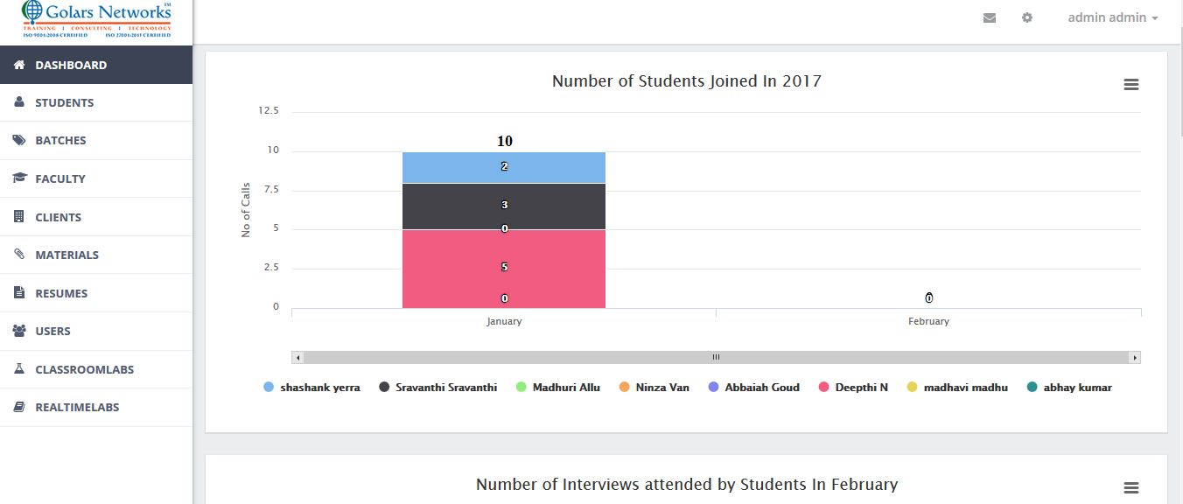

**6.2) Students:**

* Total Student Details will appear in The Students Table With all Details, Status and View of each student as shown below.

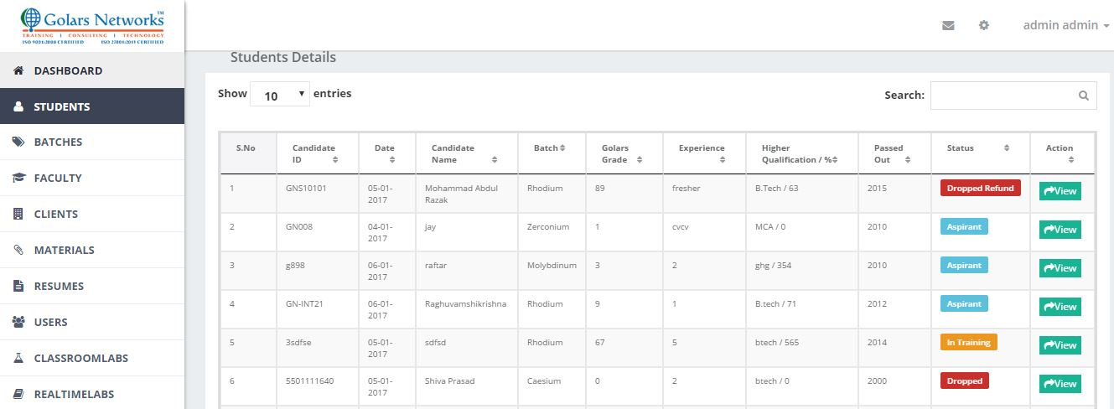

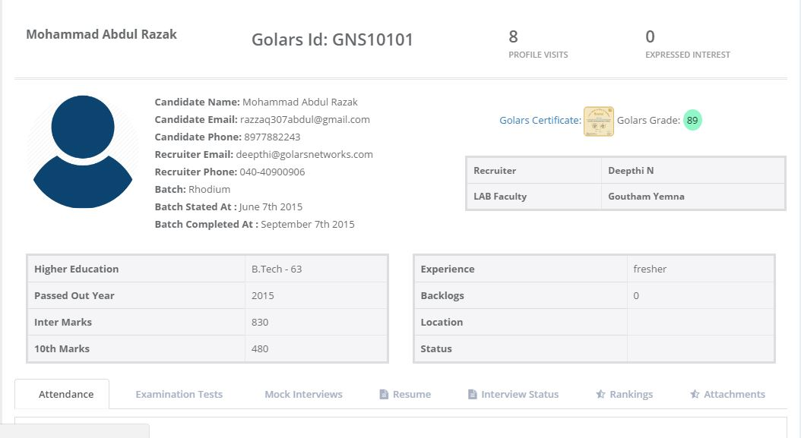

**6.3) Batches:**

* Administrators has a permission to add New Batches, Assign Faculty wise and Technology wise with start date and end date as shown below.

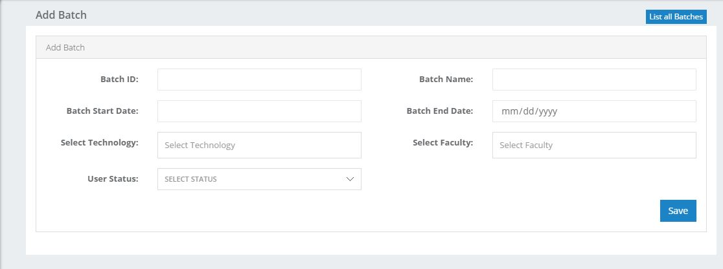

* Total Batch Details will appear in the Batch Table as shown below.

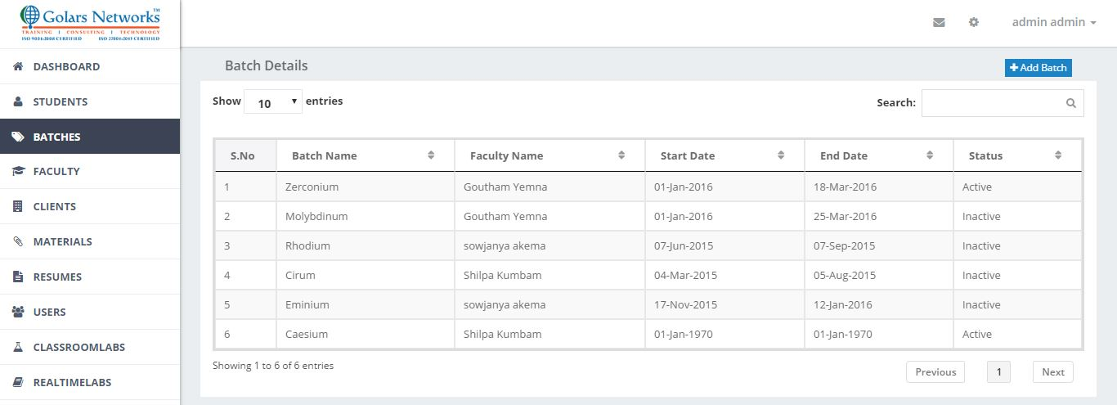

**6.4) Faculty:**

* Administrators has a permission to add New Faculty, Assign Which Technology They have to work as shown below.

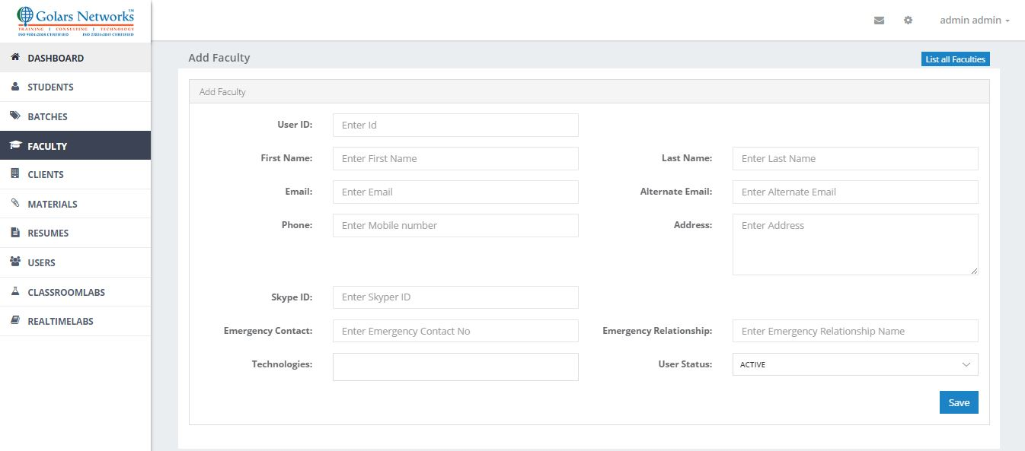

* Total Faculty Details will appear in The Faculty Table as shown below.

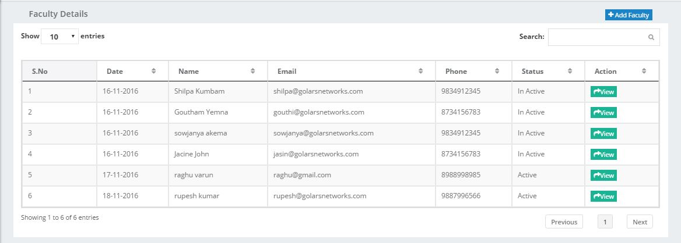

* Click on View Button You Will Get Details, how many Students are Assigned to That Faculty as shown below.

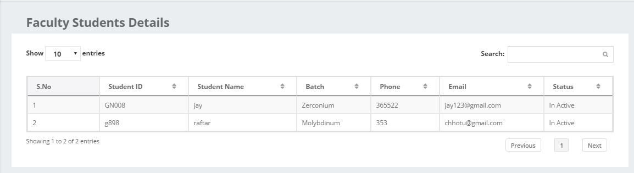

**6.5) Clients:**

* Administrators has a permission to add New Client as shown below.

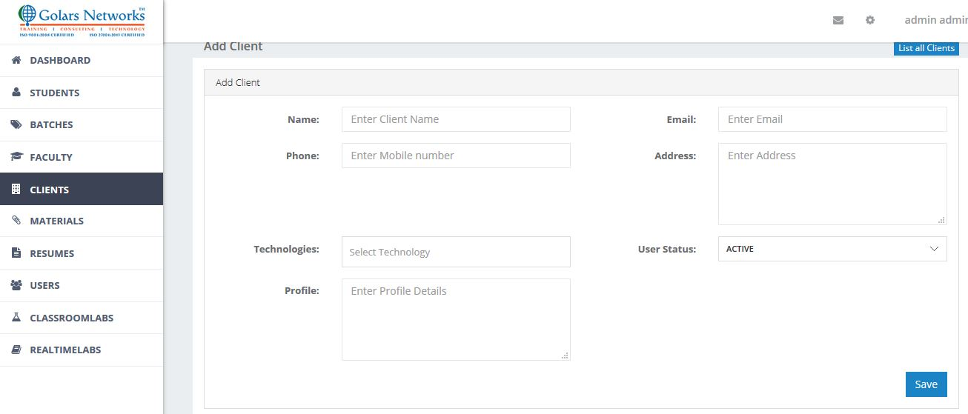

* Total Clients Details will appear in The Client Table as shown below.

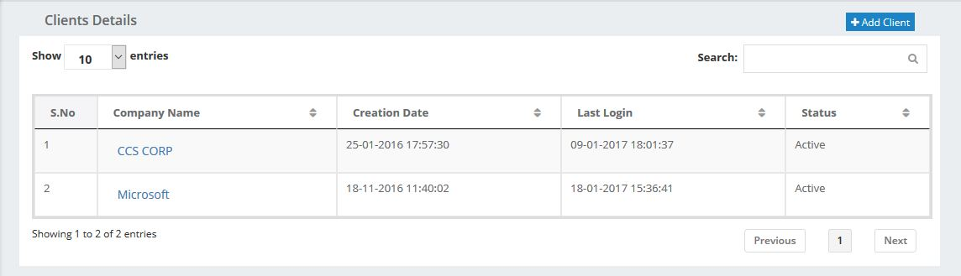

**6.6) Materials:**

* Administrators add Materials based on the batches and courses to one student or many students.
* The one who is in the that batches and same course Admin can allot the material to that student or Students by Check the Checkbox’s.
* Admin can add Four Attachments at a time.

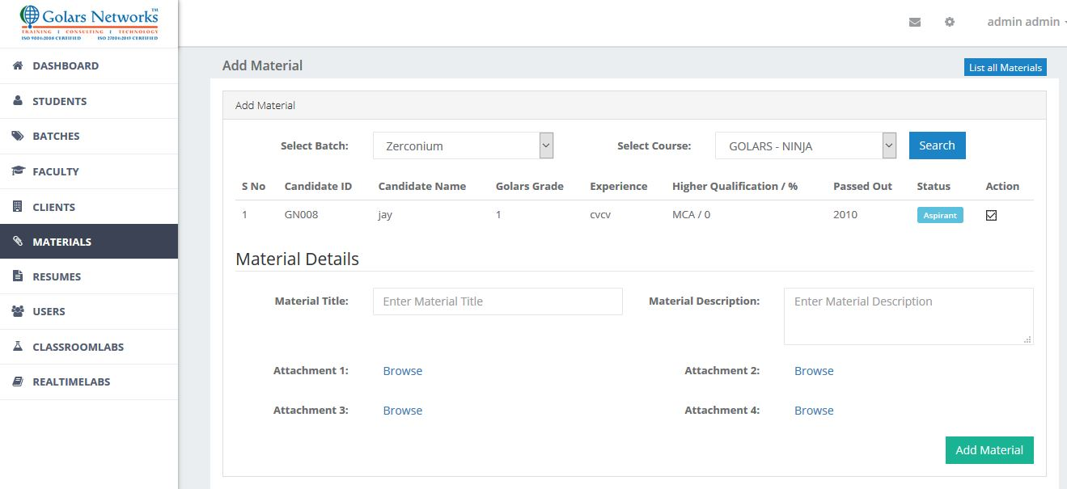

* Total Materials Details will appear in The Materials Table as shown below.

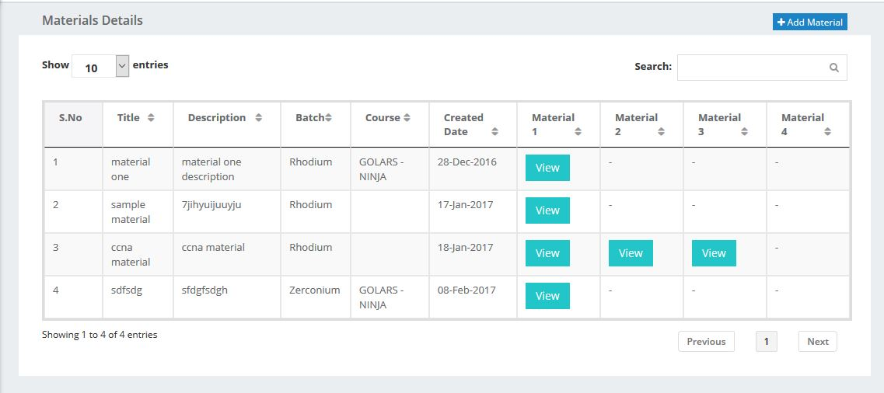

**6.7) Resumes:**

* Total Resumes Details will appear in The Resumes Table Student wise as shown below.

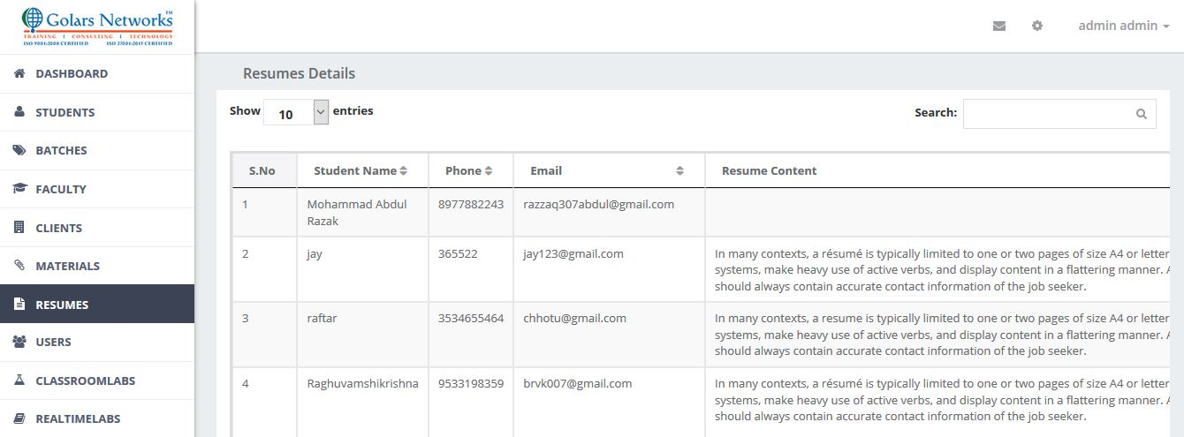

**6.8) Users:**

* Total User Details will appear in The User Table as shown below.by clicking view button see their profile.
* Click New User button admin can add new user.

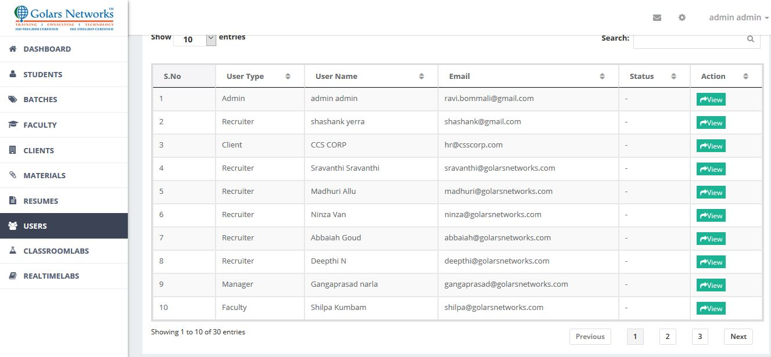

* Admin can add student, Recruiter, US Recruiter, Faculty, BDM Team, Manger, and Client in the Add User Form.
* First Admin select Designation based on that User Forms will change.

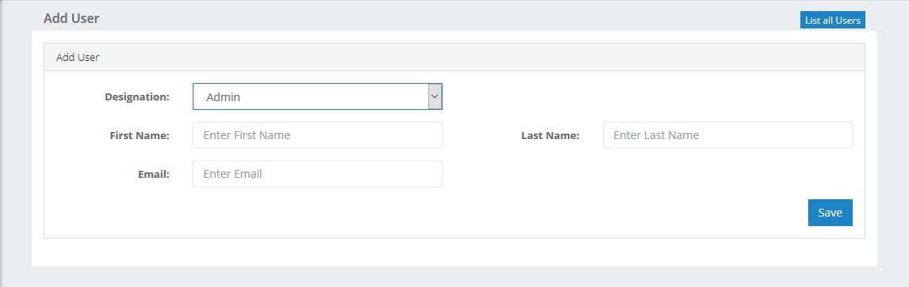

**6.9) Classroom Labs:**

* Admin can see Classroom Labs details with topic name and attachments as shown below.

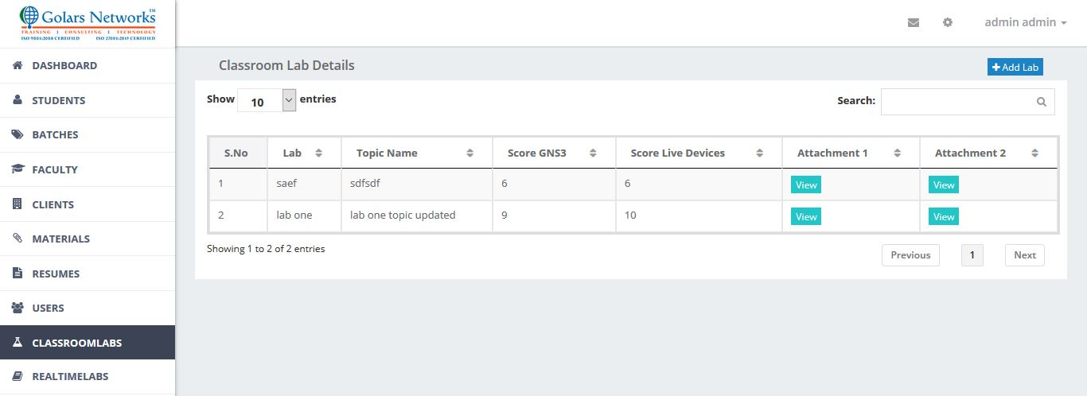

* Admin can Add Batch and course wise Classroom Labs with topic name and attachments as shown below.

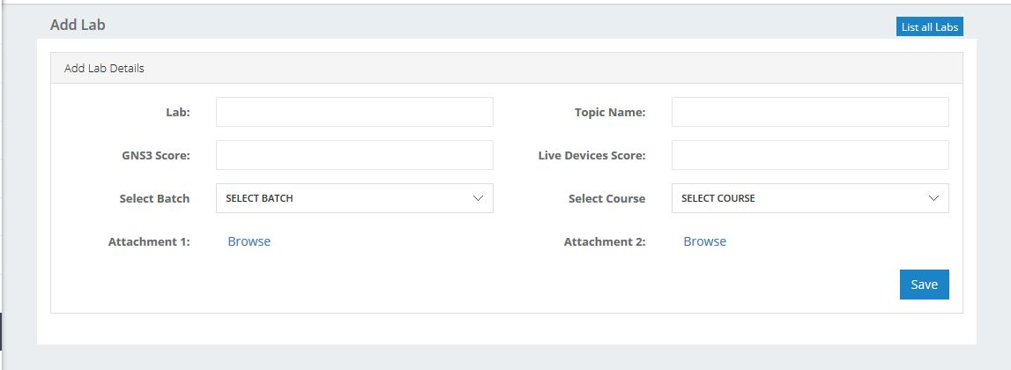

**6.10) Real-time Labs:**

* Admin can see Real-time Labs details with topic name and attachments as shown below.

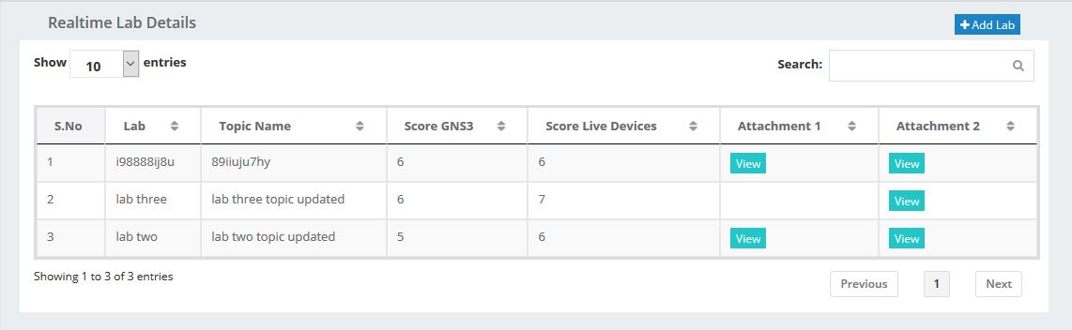

* Admin can Add Batch and course wise Real-time Labs with topic name and attachments as shown below.

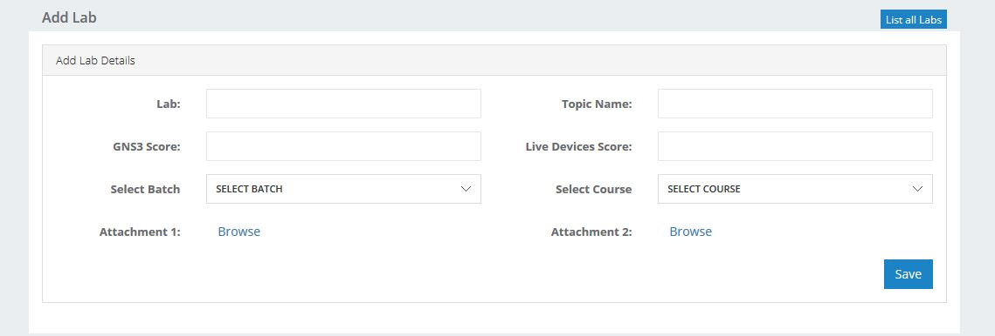

**6.11) Configuration:**

* Admin can change General Settings of the Application. That is Application name, State, Country, Language, Time Zone, Etc.

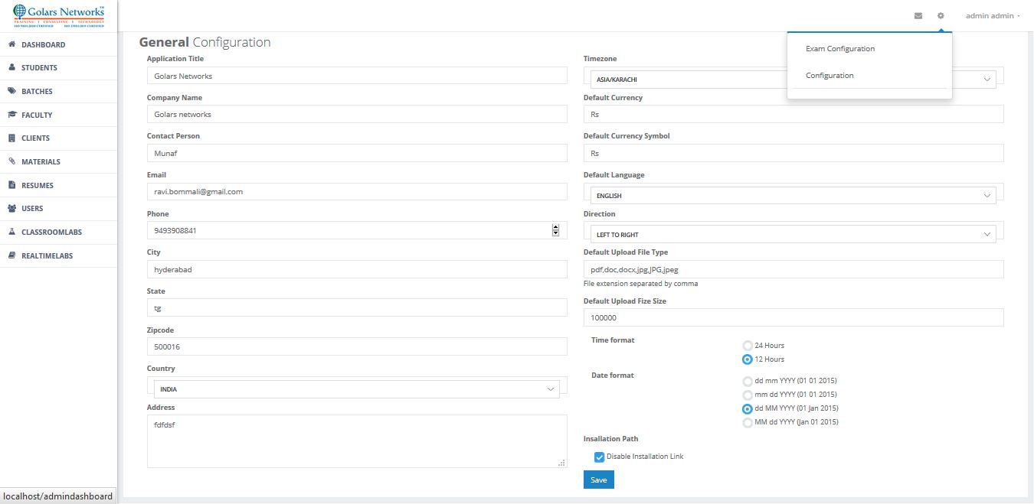

* Admin can Create New Role and Manage Permissions. Permissions are assign to based on Roles. And, Admin can Edit and delete Roles.

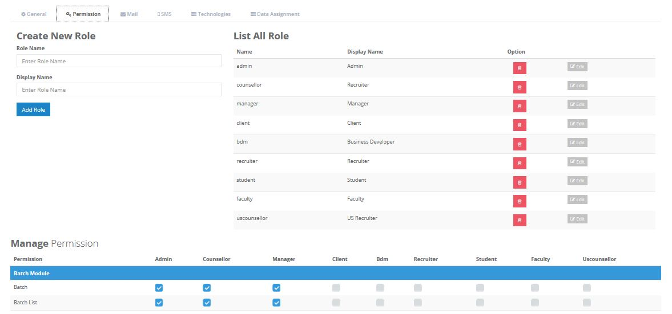

* Admin can Create, Edit, Delete New Technology.

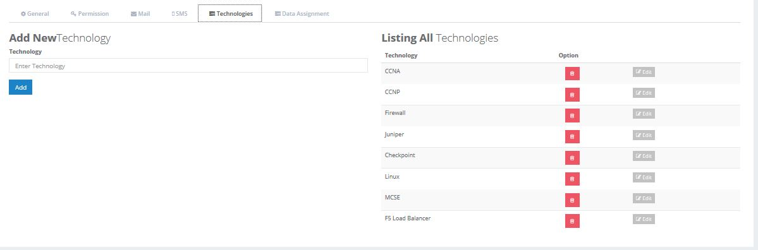

* Admin can Setup Their Mail Setup and SMS Setup in The Configuration of Mail and SMS.

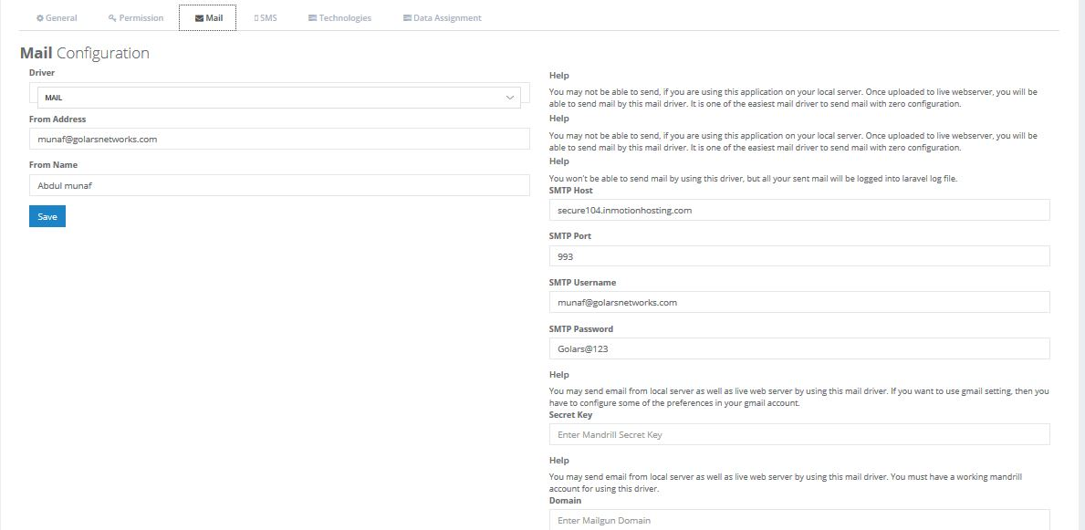

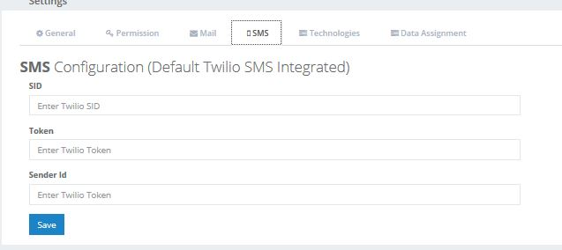

* Admin can Assign One Recruiter Entire Data of Students to another recruiter by using Data Assignment.
* Suppose One Recruiter has left out the job new recruiter is join in that job, Admin give new role to new one and assign old recruiter entire data to new one. This is main advantage of Data Assignment

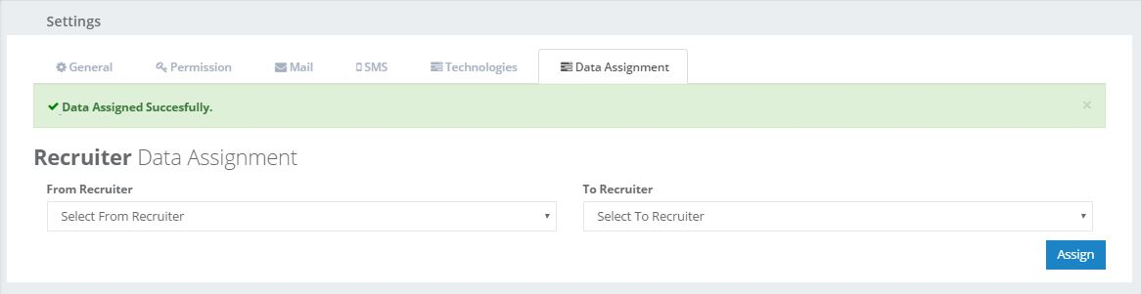

# **7. Exam Configuration Submodule of Admin:**

**7.1) Categories:**

* Admin have permissions to add new categories and its status by clicking on Add New Category.
* Admin Can Edit and Delete the Categories.
* Total details of the Category will have displayed in Table Form with Status Wise.

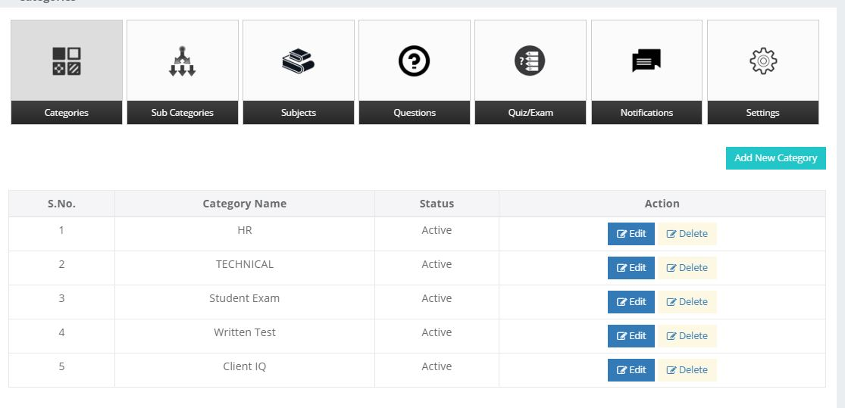

Add Category

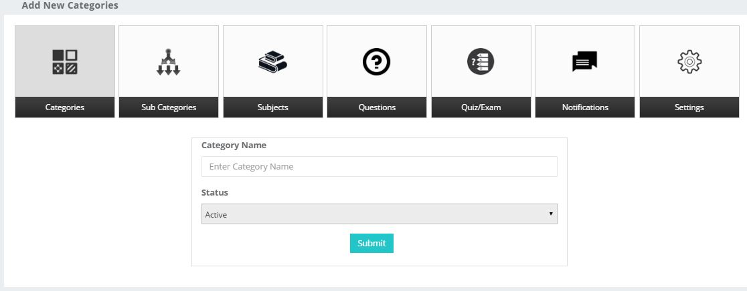

Edit Category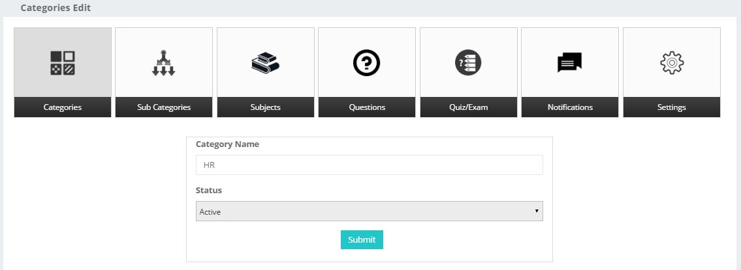

Delete Category

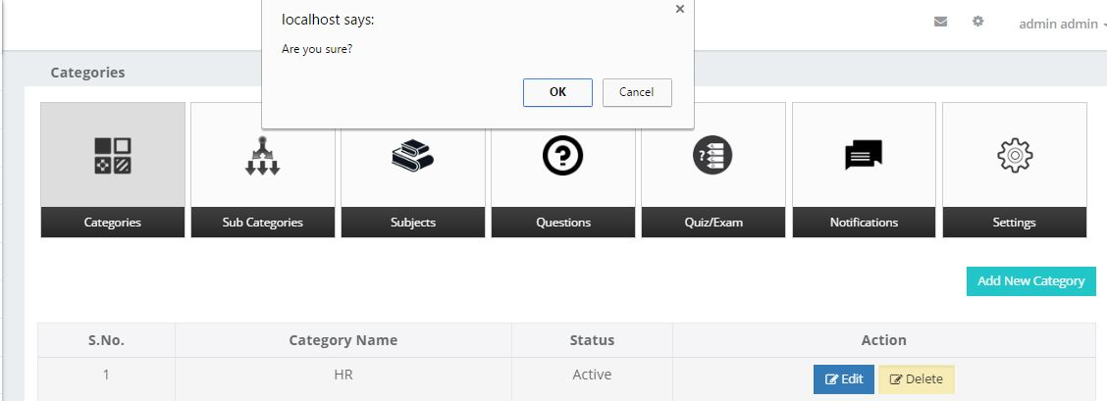

**7.2) Sub Categories:**

* Admin have permissions to add new sub categories and its status by clicking on Add New Sub Category to the categories.
* Admin Can Edit and Delete the Sub Categories.
* Total details of the Sub Category will have displayed in Table Form with Status and Category Wise.

Add Sub Category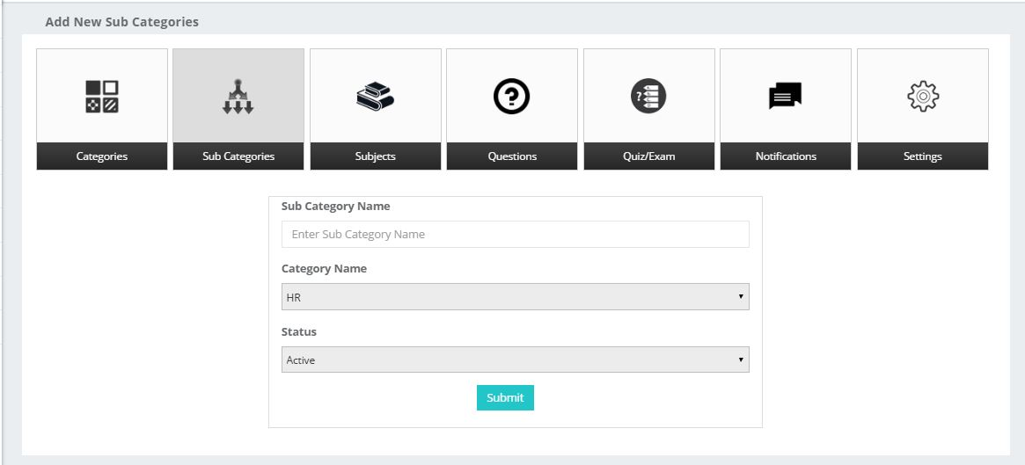

Total Details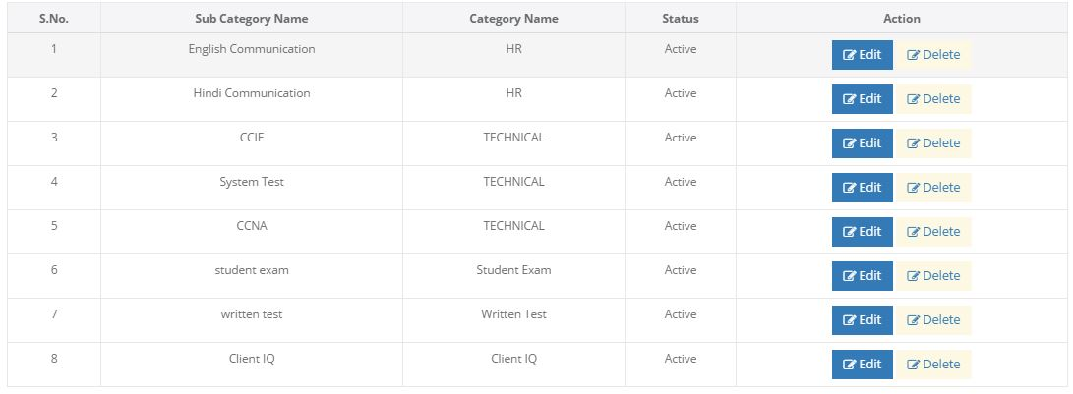

Edit Sub Category 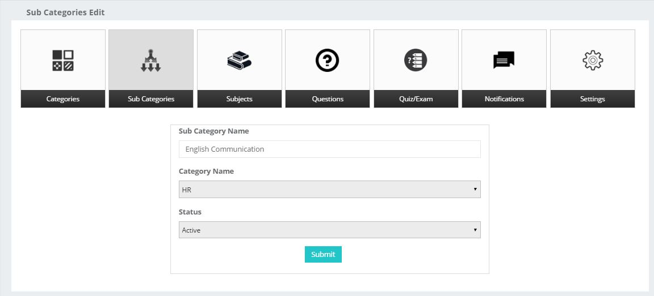

Delete Sub Category

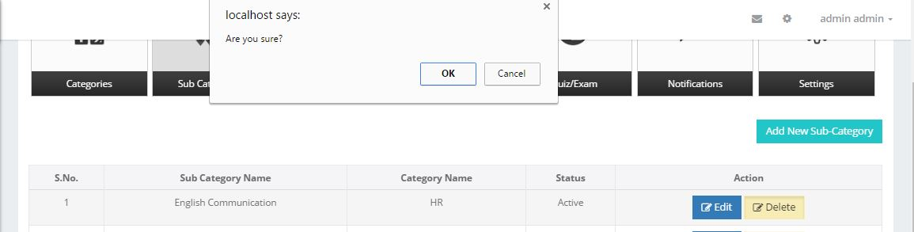

**7.3) Subjects:**

* Admin have permissions to add new subjects and its status by clicking on Add New Subjects.
* Admin Can Edit and Delete the Subjects.
* Total details of the Subjects will have displayed in Table Form with Status Wise.

Total Subjects Details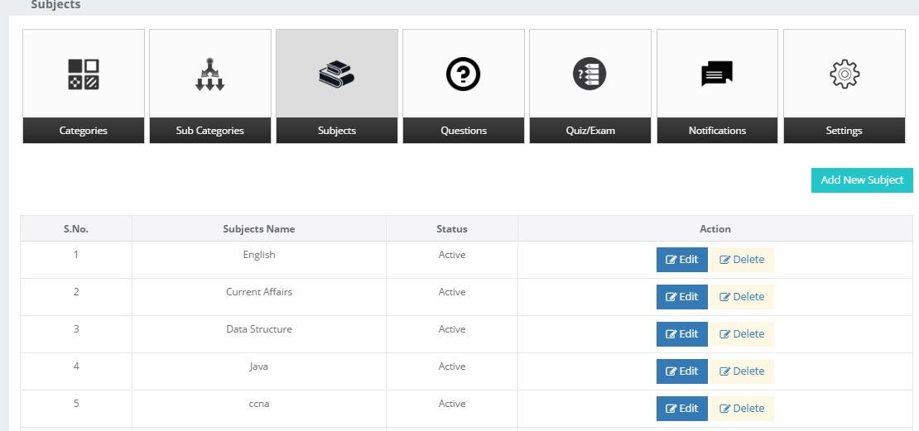

Add New Subject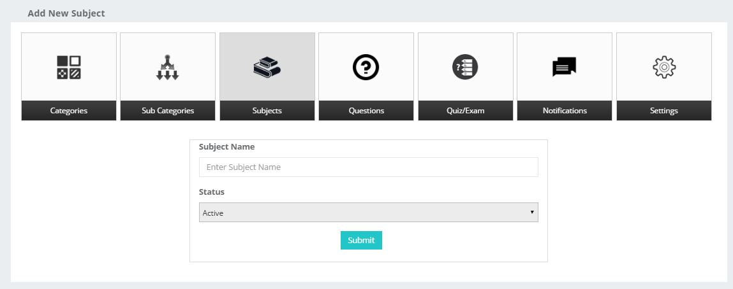

Edit Subjects

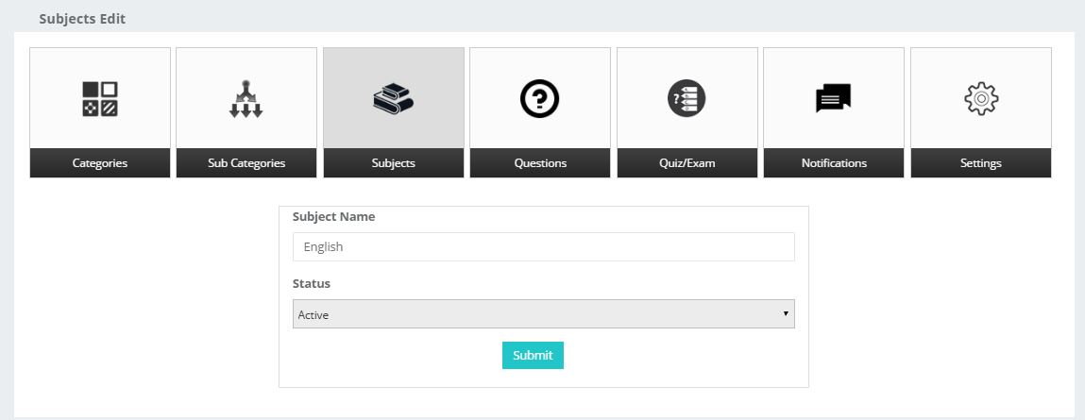

Delete Subjects

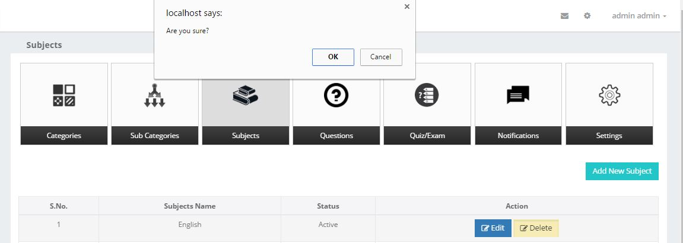

**7.4) Questions:**

* Admin have permissions to add new Questions and its status by clicking on Upload Questions.
* View, Edit, Delete the Questions Subject wise.
* Add the Questions subject wise, Question type, and difficulty level.

Upload Questions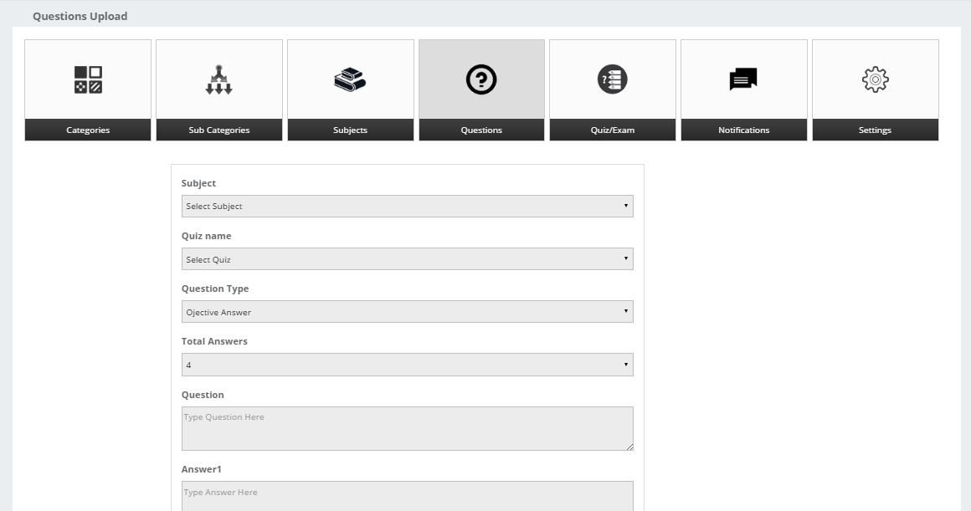

Details of Questions Subject Wise.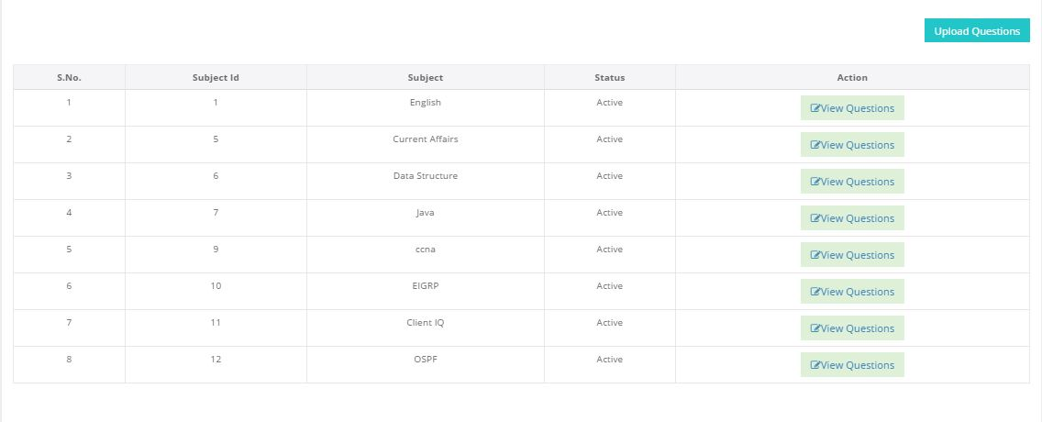

Details of one subject here admin can edit delete questions.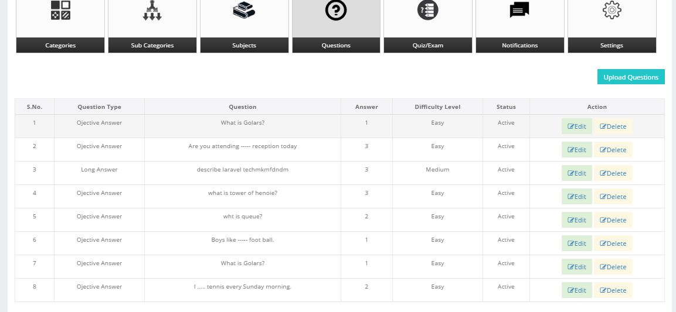

Edit the Questions by clicking edit button. 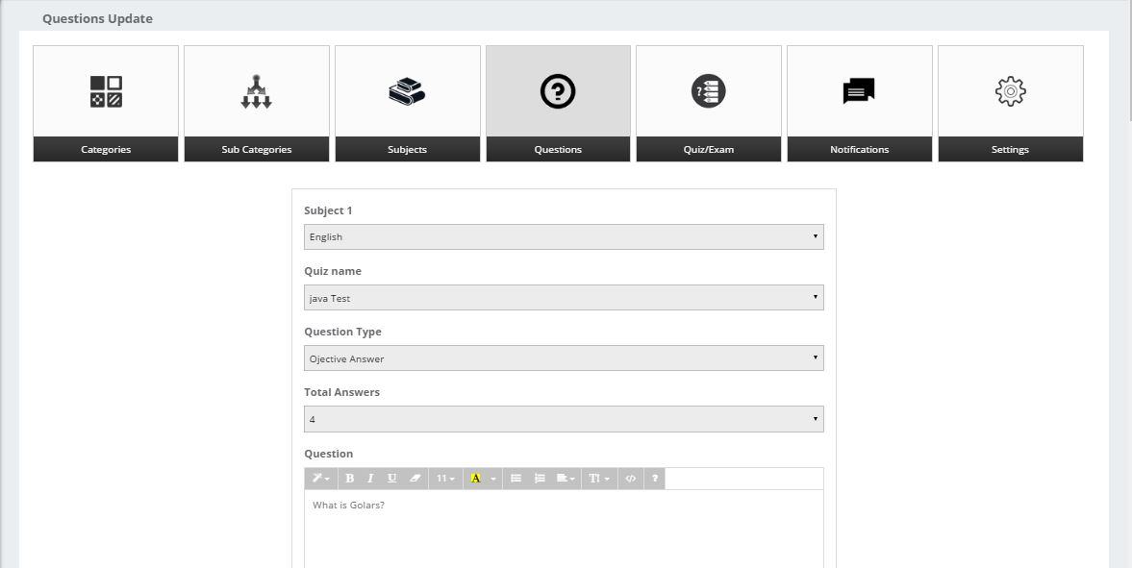

**7.5) Quiz/Exam:**

* Admin have permissions to add new Quiz/Exam and its status by clicking on Upload Quiz.
* View, Edit, Delete the Quiz.
* Add the Quiz Category, Sub Category, Quiz Type, and difficulty level.

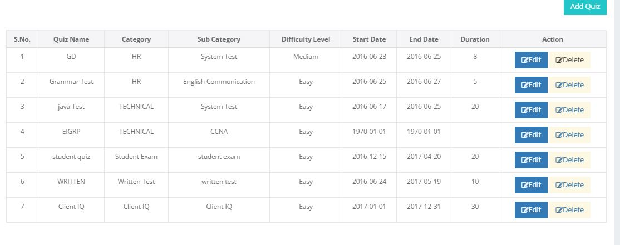

Add Quiz/Exam.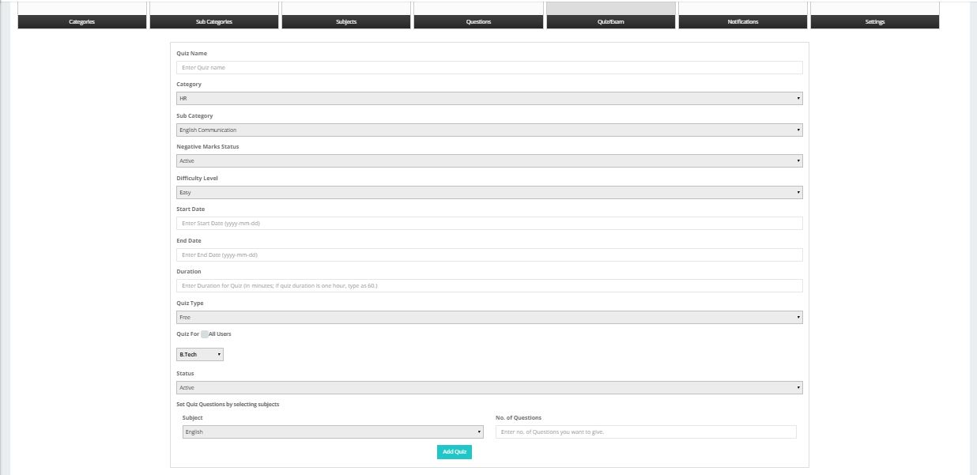

Edit Quiz/Exam.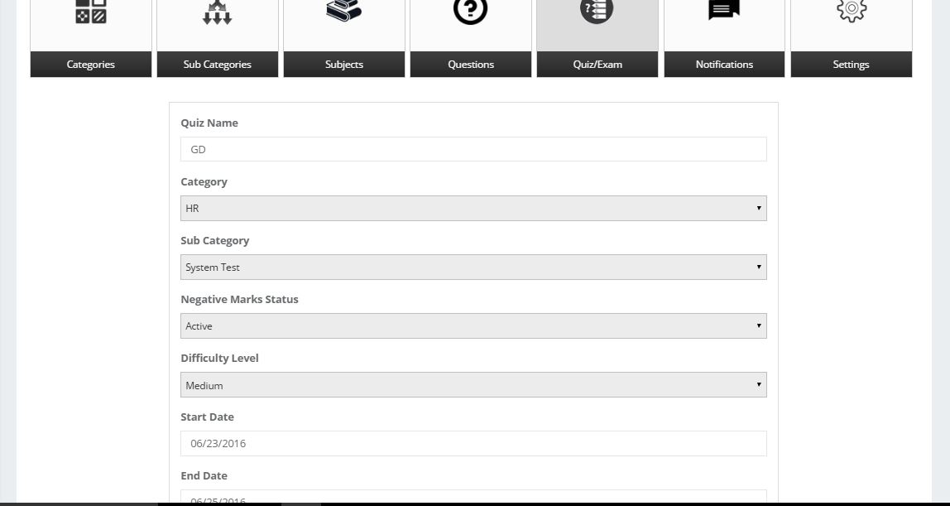

Delete Quiz/Exam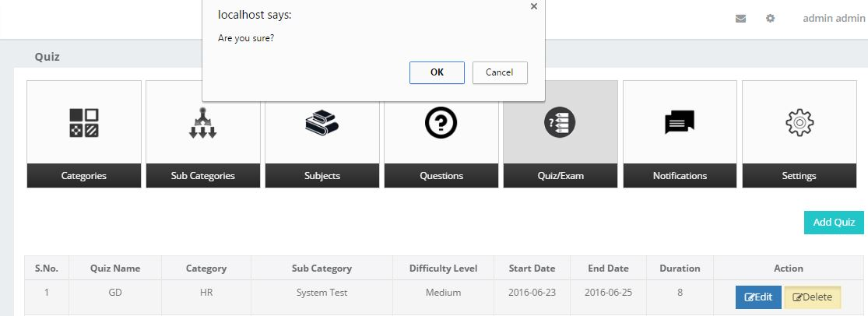

**7.6) Notifications:**

* Admin have permissions to add new Notifications.
* View, Edit, Delete the Notifications.

Add New Notification

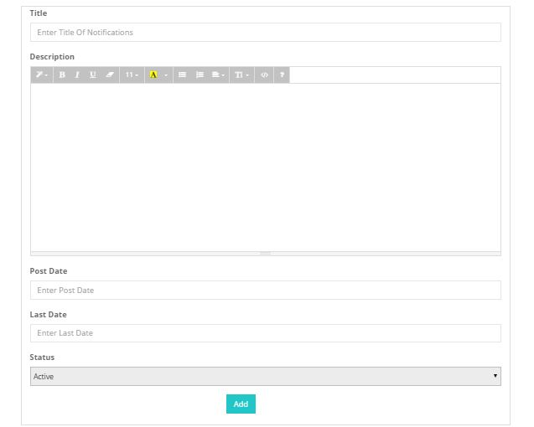

Edit Notification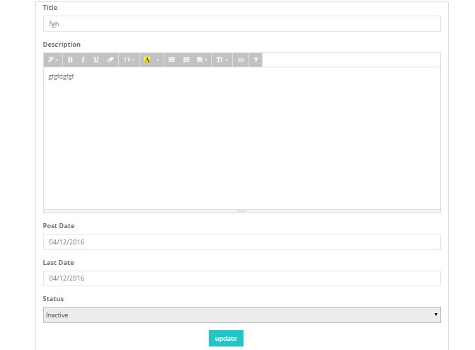

List All Notification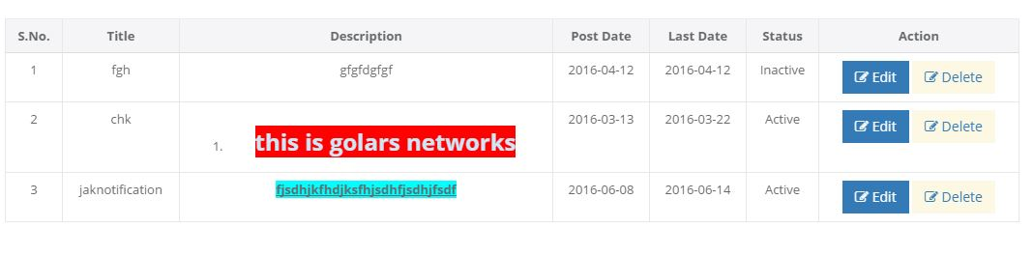

# **8.Counselor Module:**

**8.1) Dashboard:**

* Counselor has a complete record of, Interview Schedules, Candidate details, Recent Activities, Quick Message.
* Counselor can add Candidates, and Their Attendance, and see Referral list.
* Counselor add Batches, and see faculty, list of jobs.
* Counselor see the all student details status wise, Students are aspirants, in training, placed, dropped, and dropped refund.
* See the Tickets if any student will raise any issue.

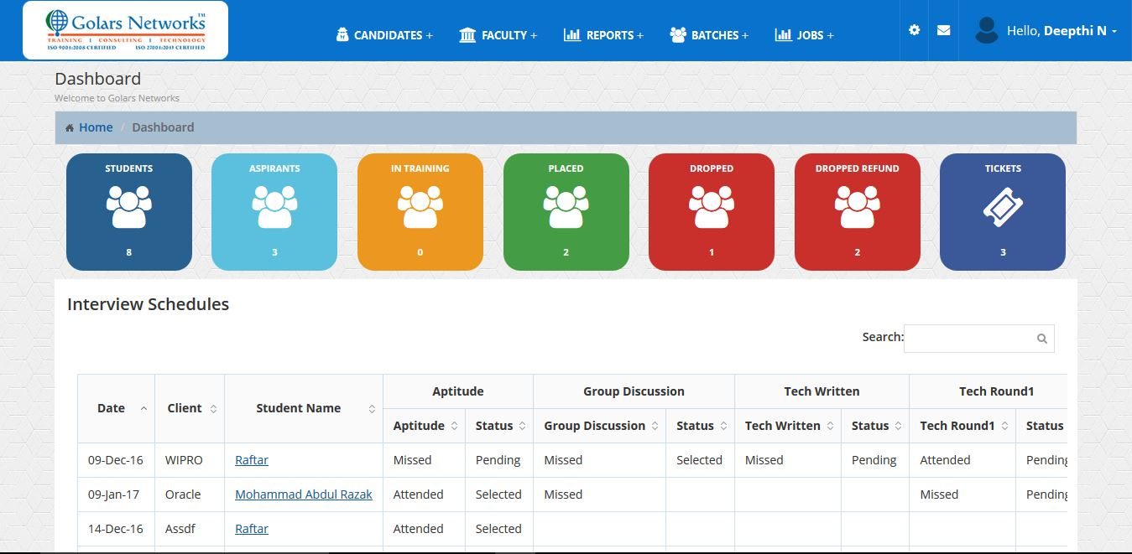

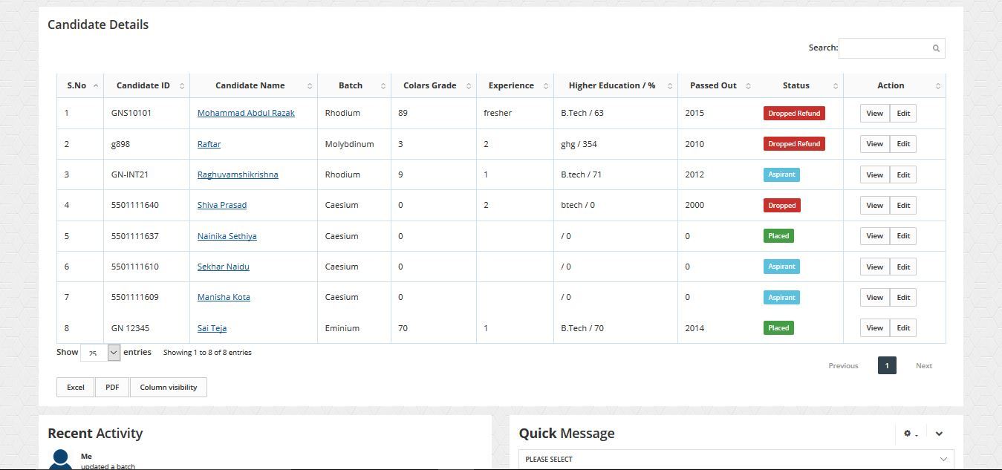

**8.2) Candidates:**

* In Candidates Module Counselor, can add new candidate and give an attendance to their students.
* In Candidates Module Counselor, can See candidates who are assign to him, and referral list.

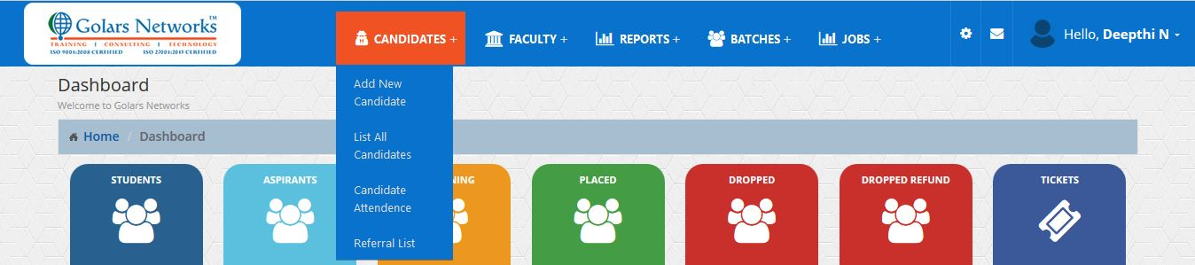

**8.2.1) Add New Candidate:**

* Counsellor Add New Students as shown below.

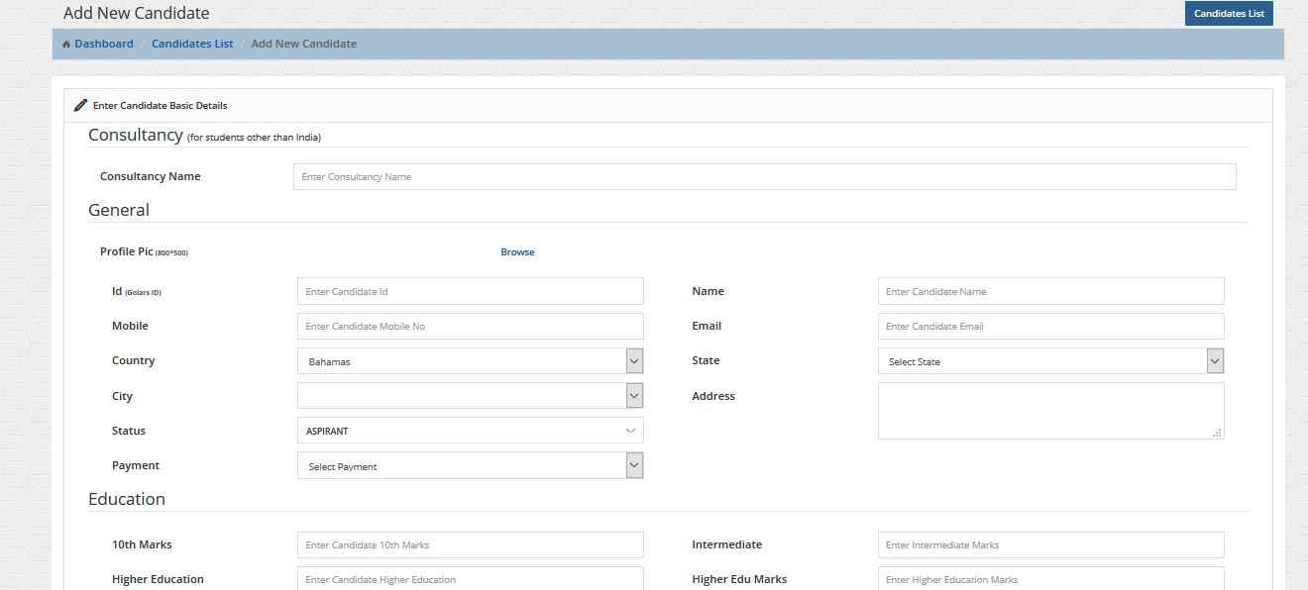

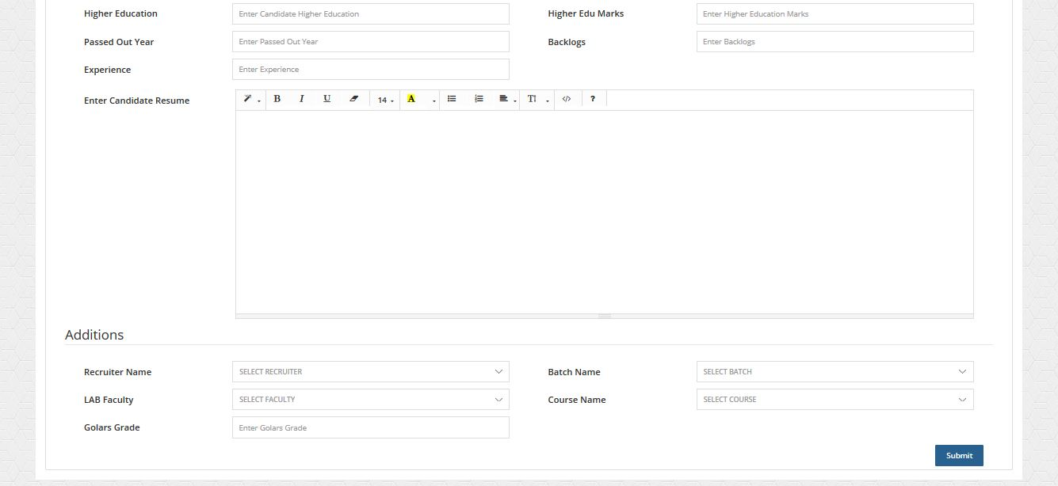

**8.2.2) List all Students:**

* Counsellor see all student’s details who are added by him and who are assign to him by admin, as shown below with status.

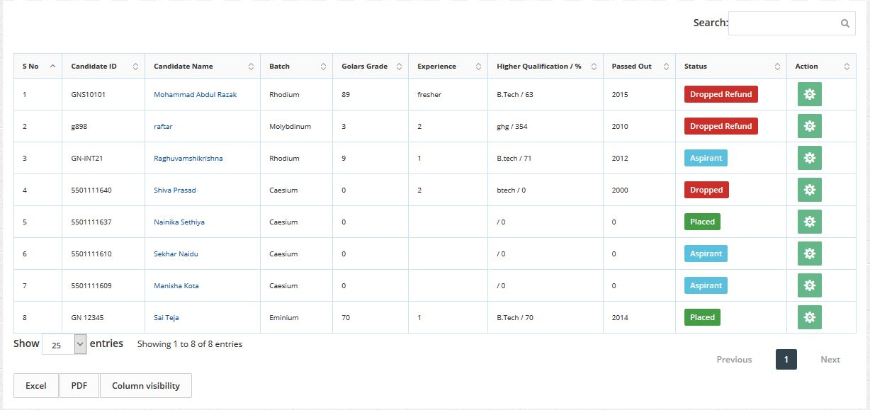

**8.2.3) Candidate Attendance:**

* Counsellor see all student’s present and absent list with batch name and class name in the table form as shown below.

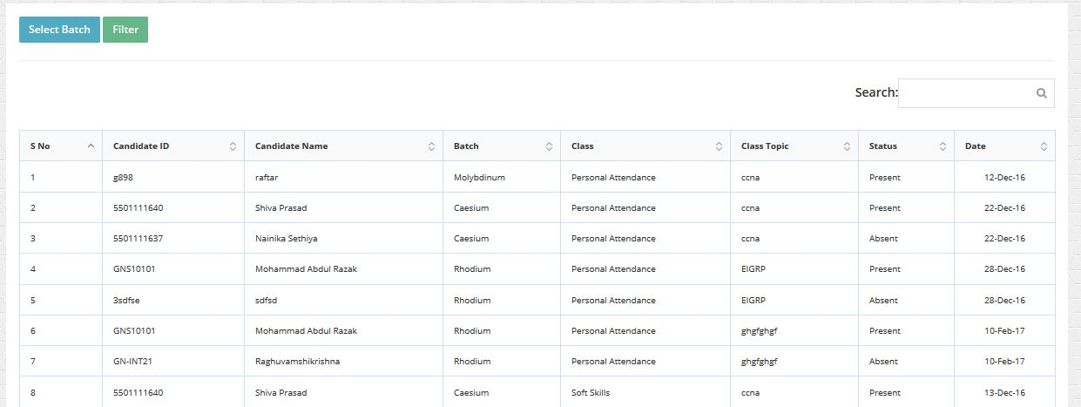

* Counsellor want to give an attendance first select batch in the dropdown and click the filter button.
* It will show all student list present in that batch.

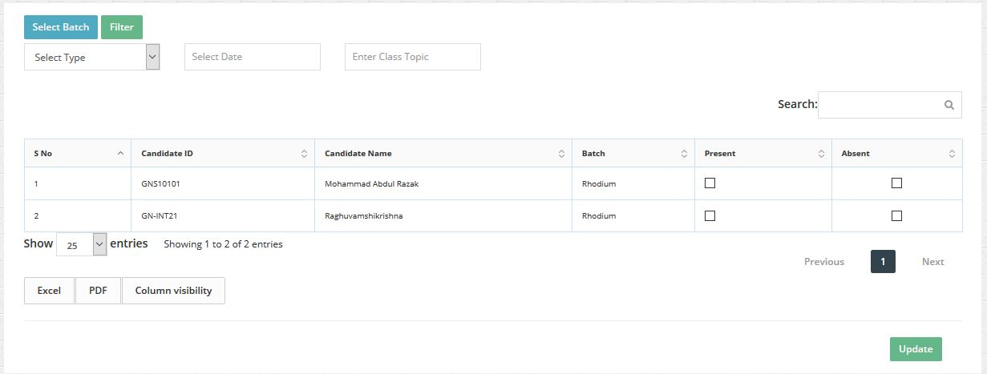

* Select Type class and select date and enter class topic.
* If a student present, check the Present check box else check the absent. Click update.

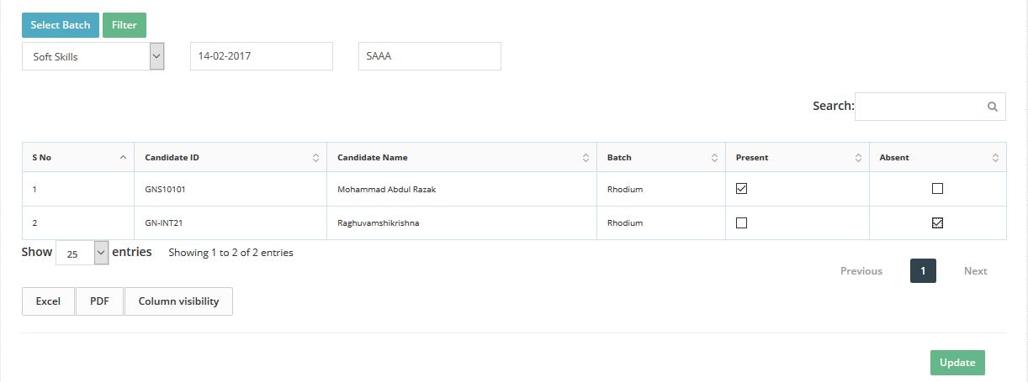

**8.2.4) Referral List:**

* If any Students is referred his friend, Counsellor will see the Refer name, mail, Mobile and Referred student name as shown below.

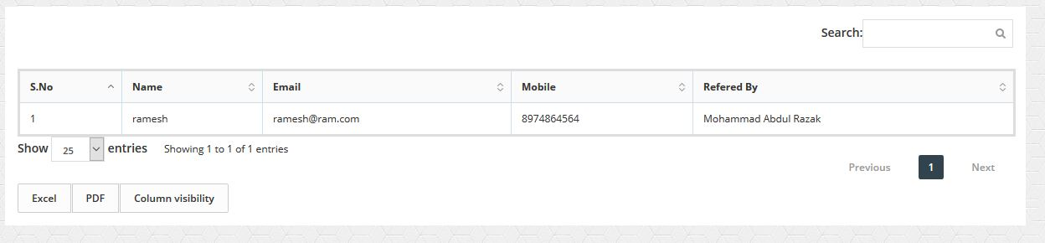

**8.3) List all Faculty:**

* Counsellor see all Faculty Details and See Full Profile of One Faculty with assigned student’s data and have permissions to edit it, as shown below.

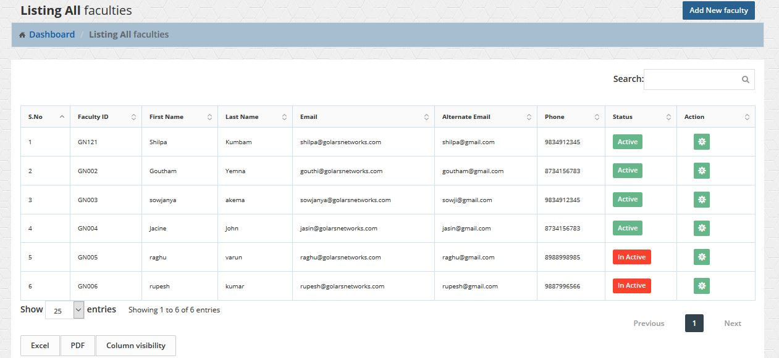

* Profile of Faculty with assigned students to faculty as shown below.

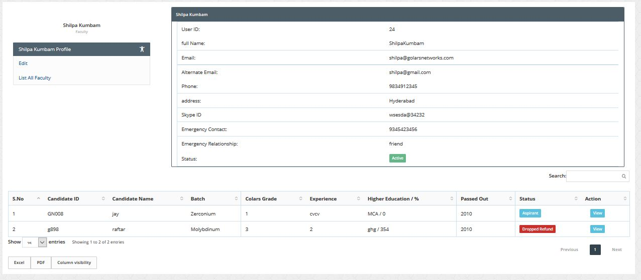

**8.4) Reports:**

* Counsellor see Reports of Students Status and Placed Student’s Batch Wise in Graph.

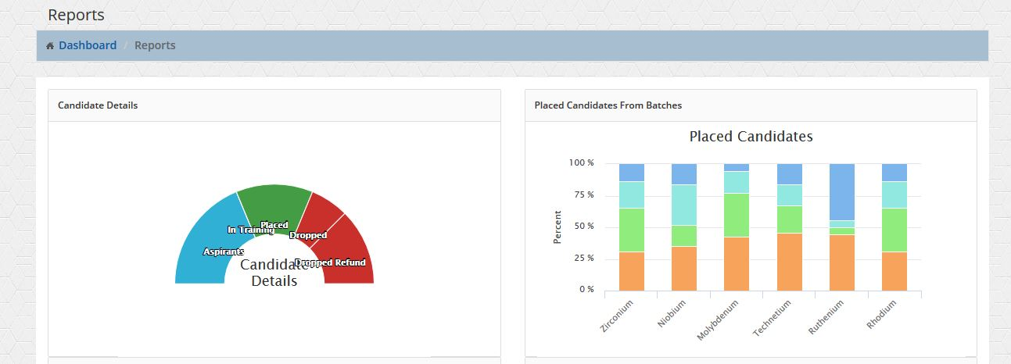

* Counsellor see Reports of Academic Percentage of Batch Wise and Placed Candidates from Recruiter in Graph.

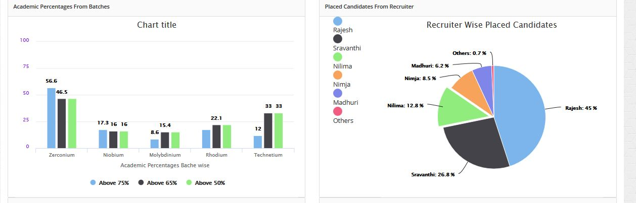

* Counsellor see Reports of Companies Recruited Candidates and Monthly Average Visited the Students as shown in Graph below.

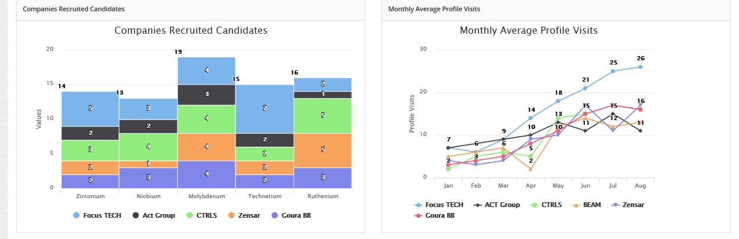

**8.5) Batches:**

* Counsellor can add batches and see all batches.

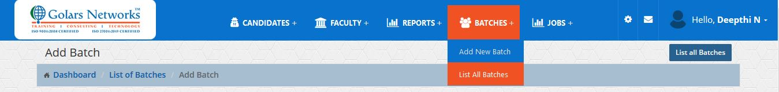

**8.5.1) Add Batches:**

* Counsellor can add batches with faculty, Technology, and status.

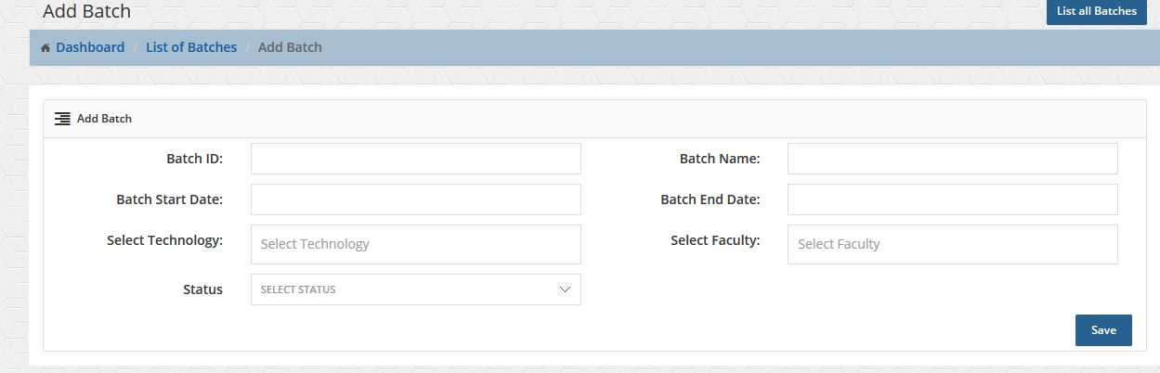

**8.5.2) List Batches:**

* Counsellor can see all batches list with faculty, Technology, and status.

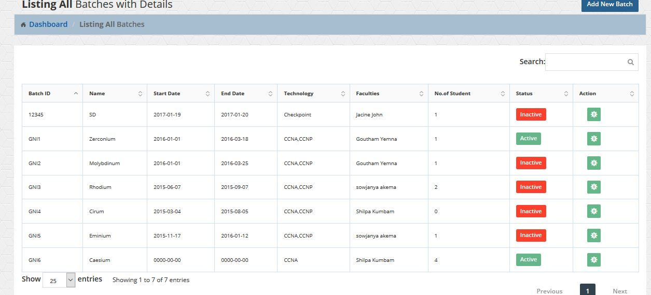

**8.6) Jobs:**

* Counsellor can see all jobs and view it.

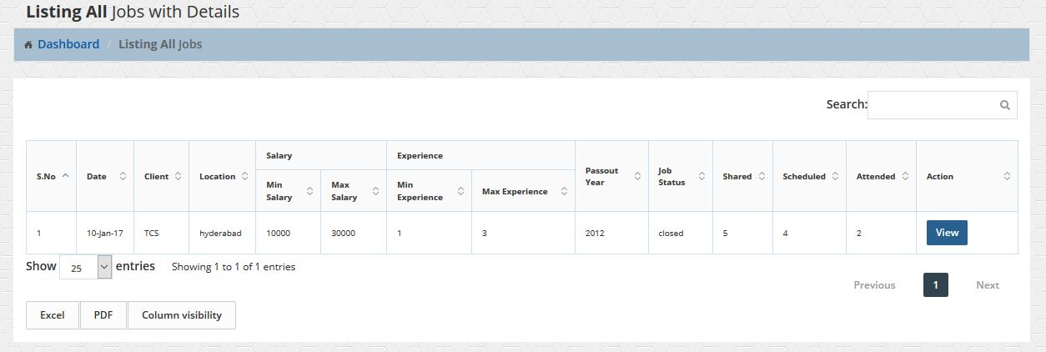

* Counsellor can schedule interviews and see how many attended and selected candidate details.
* Counsellor update each data by check the radio buttons.
* Counsellor also see full details of company and contact details.

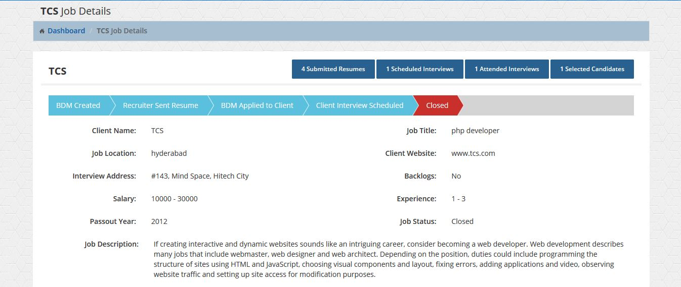

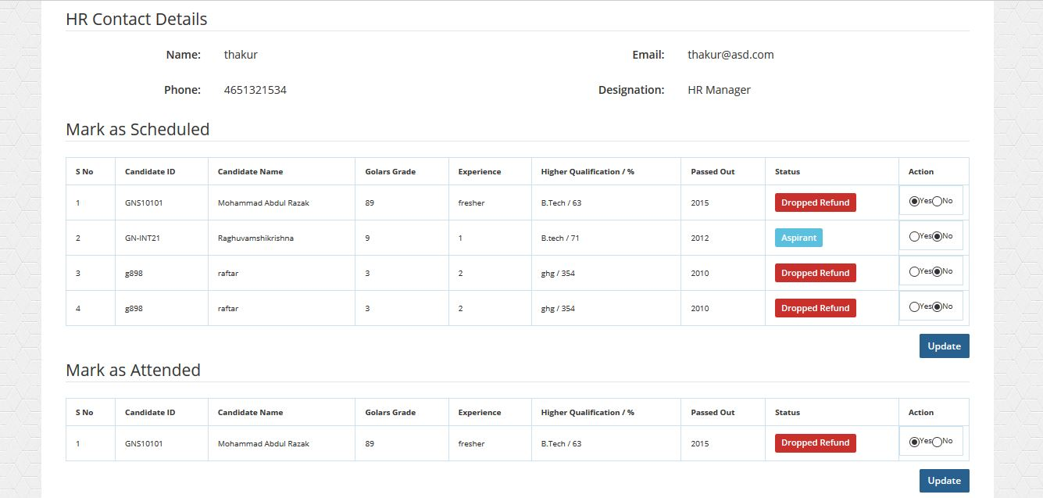

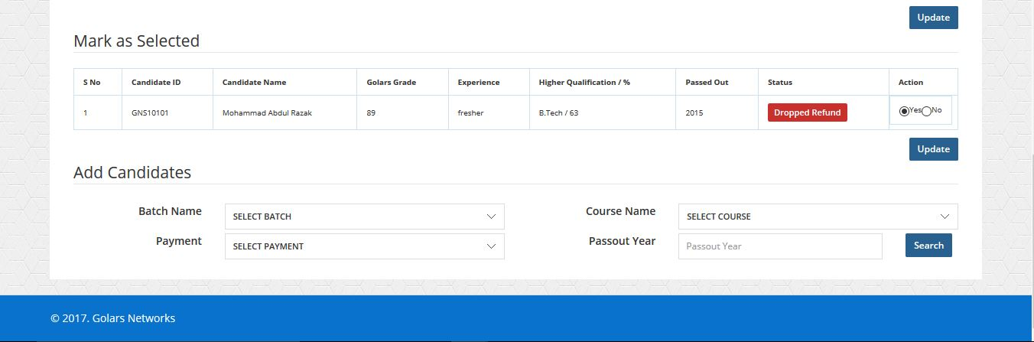

**8.7) Students:**

* Counsellor can see all details of student’s and view the profile and edit the profile of each student.

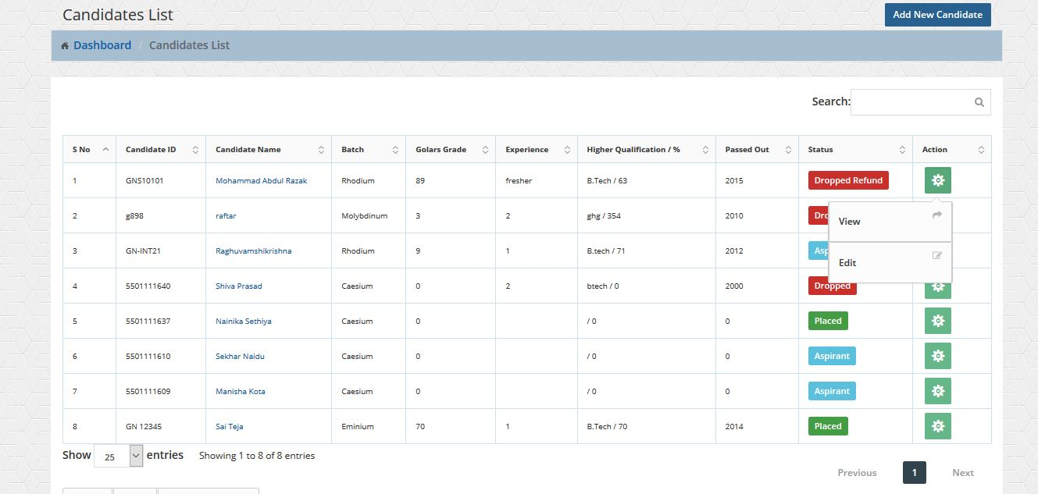

* Counsellor can edit the data of student.

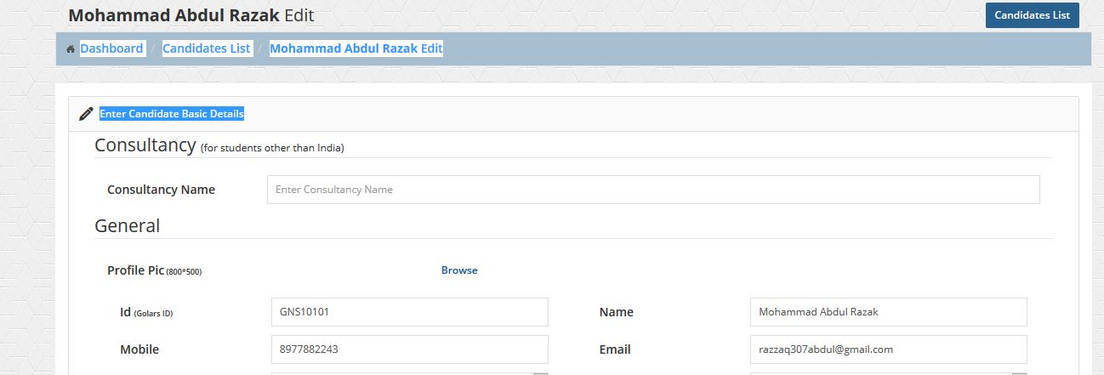

**8.8) View Students:**

* Counsellor can view the data of student and see all details of student and add mock interviews, resumes, concerns, etc.
* Full Profile of Student.

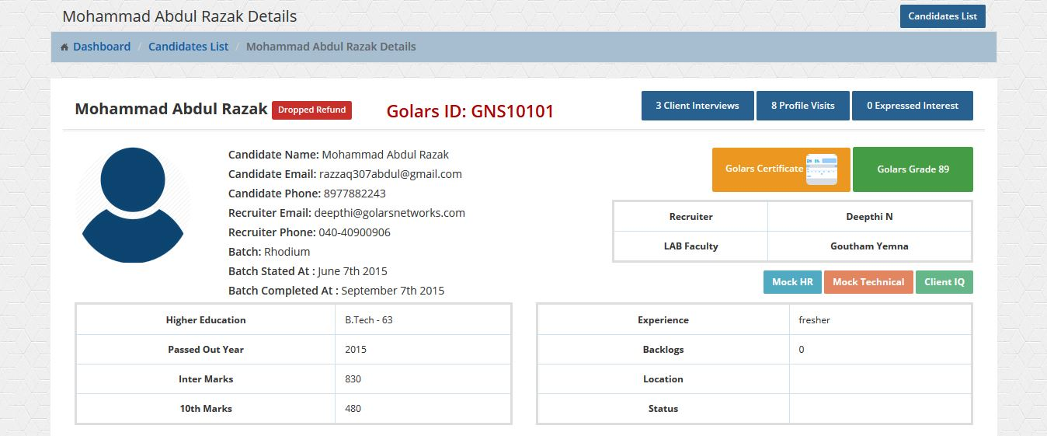

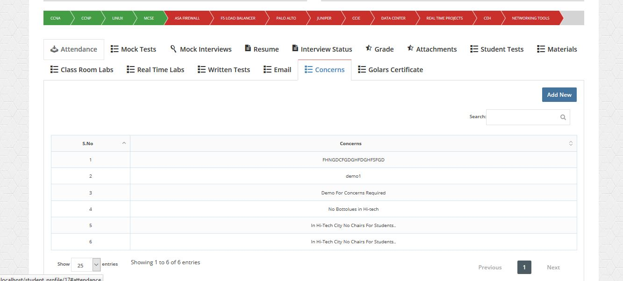

**8.8.1) Add Course:**

* Counsellor can add course to student by clicking yes or no options in breadcrumbs, if the student is joined breadcrumb will be the green else it will be the red.

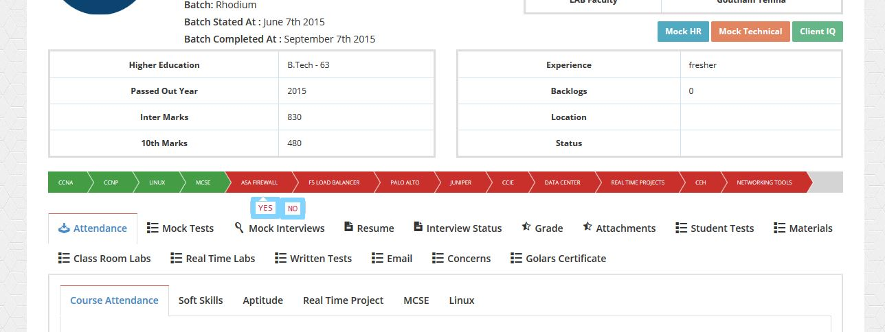

**8.8.2) Attendance:**

* Counsellor See full attendance details Class Room Wise.

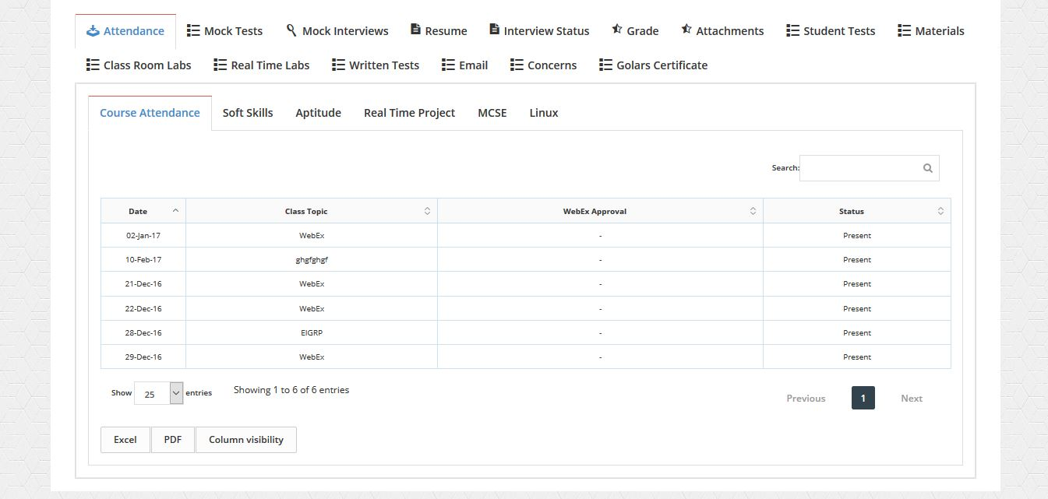

**8.8.3) Mock Tests:**

* Counsellor See student mock tests with topic name and results.

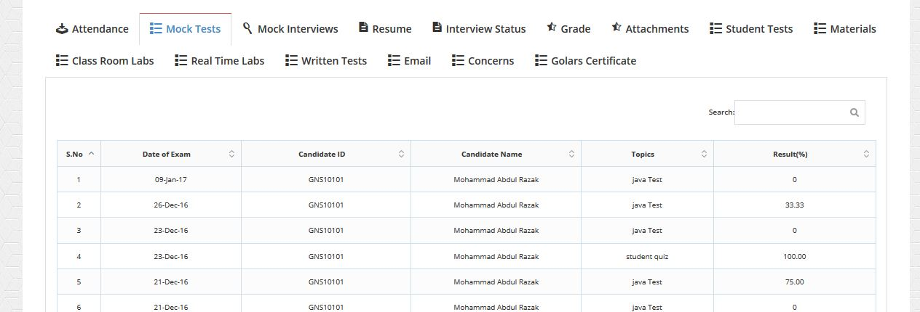

**8.8.4) Mock Interviews:**

* Counsellor add mock interviews to mock type, score, and comments and see details student mock tests with mock type name and results.
* Click add new button for adding mock interviews, click cancel button to hide mock interview form.

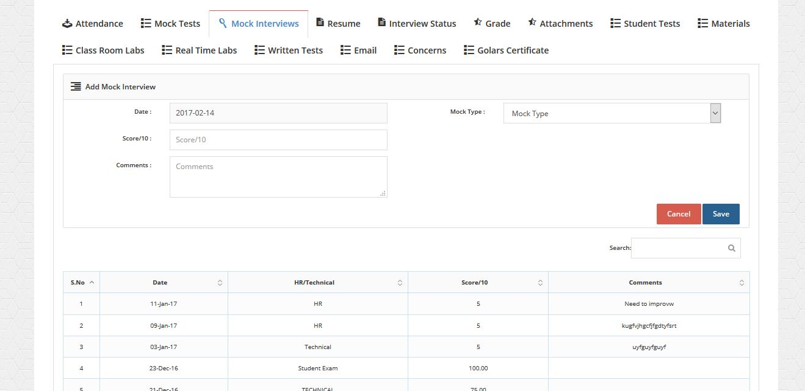

**8.8.5) Resume:**

* Counsellor add new resume and modify the existing resume and download the resume.

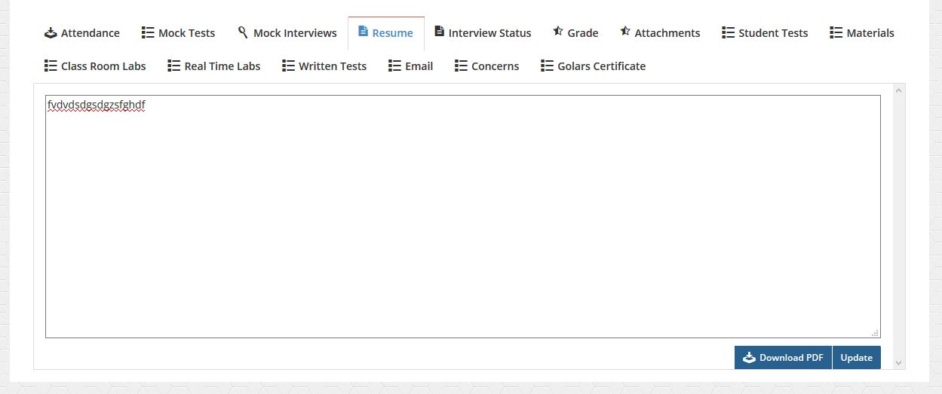

**8.8.6) Interview Status:**

* Counsellor add interview status to student, and see details of student interview status, and edit it.
* Click add new button for adding interview status of student, click cancel button to hide interview form.

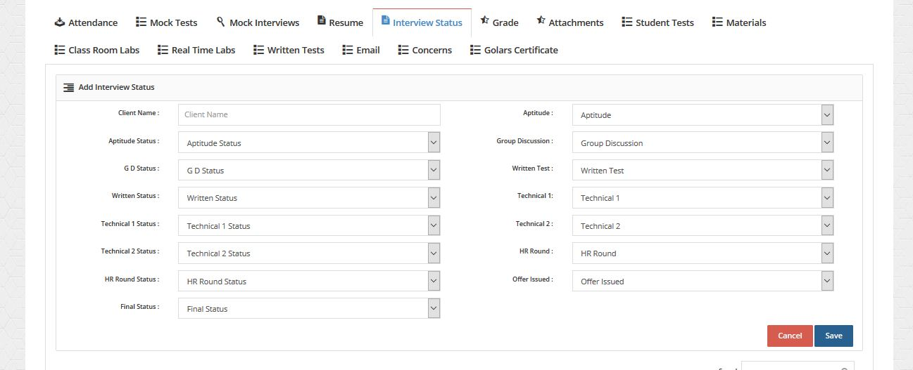

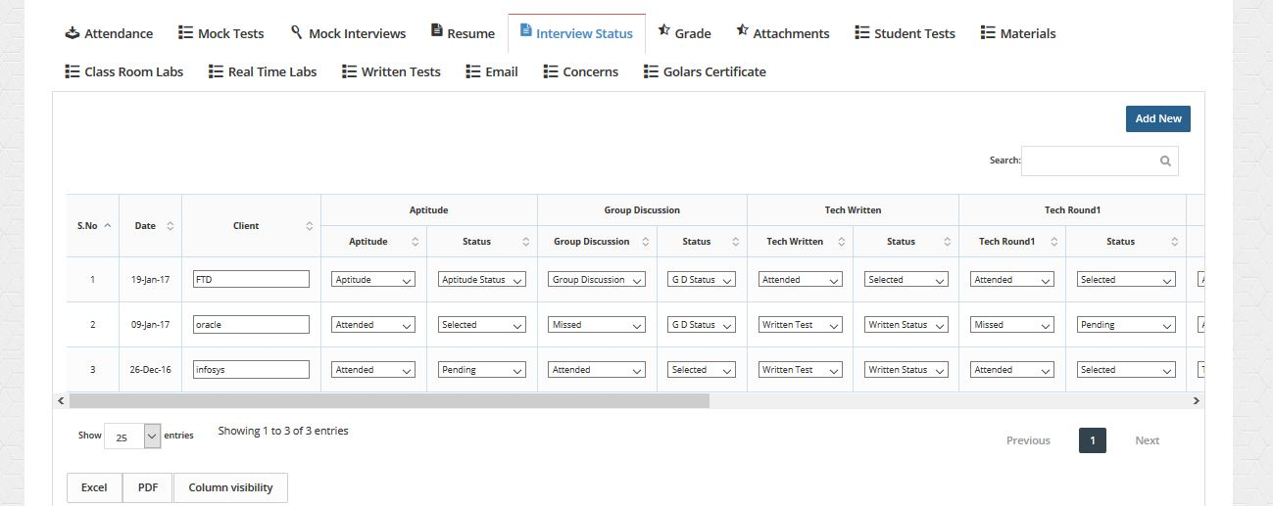

**8.8.7) Grade:**

* Counsellor add grade to student, and see details of student grade and edit it.
* Click add new button for adding grade of student, click cancel button to hide grade form.

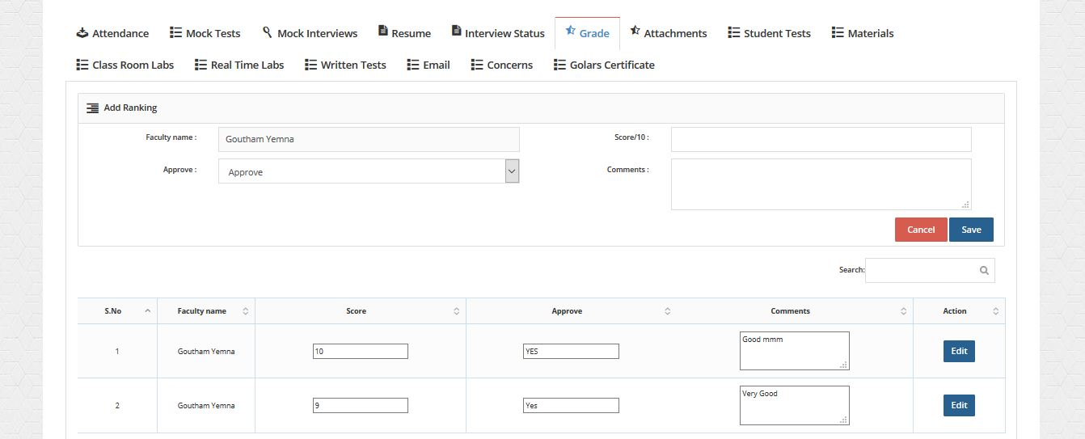

**8.8.8) Attachments:**

* Counsellor add attachments to student, and see details of student attachments, view attachments.
* Click add new button for adding attachments of student, click cancel button to hide attachments form.

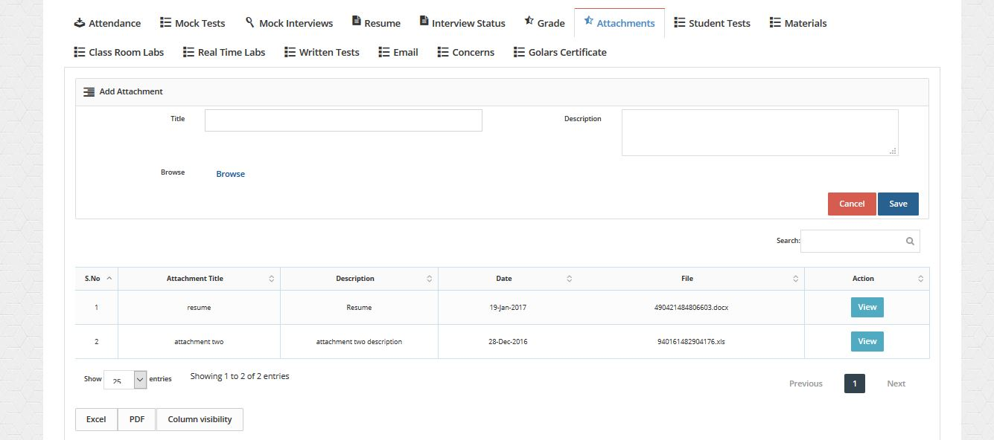

**8.8.9) Student Tests:**

* Counsellor see all details of student tests.

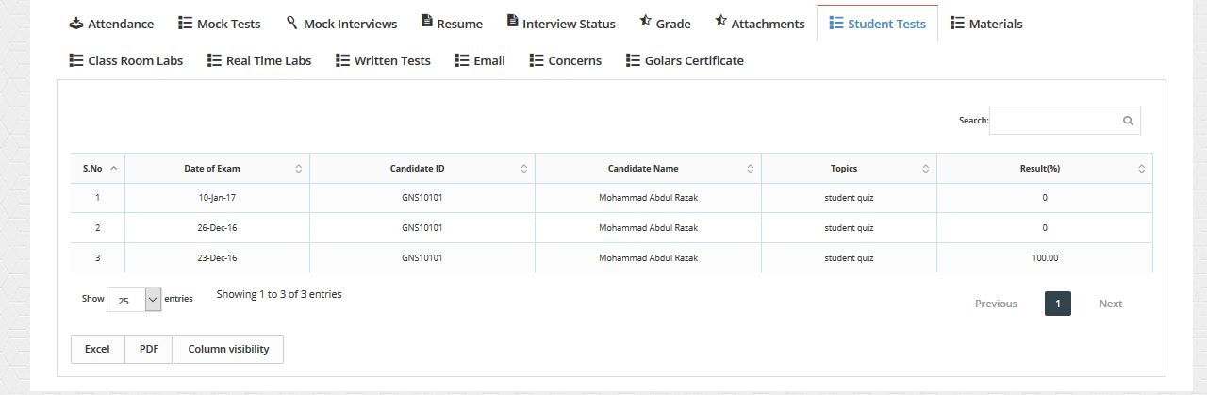

**8.8.10) Materials:**

* Counsellor add materials to student, and see details of student materials, view materials.
* Click add new button for adding materials of student, click cancel button to hide materials form.

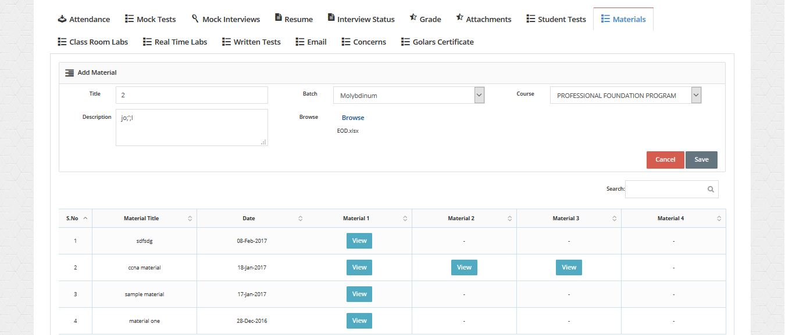

**8.8.11) Classroom Labs:**

* Counsellor add classroom labs to student, and see details of student classroom labs, view classroom labs attachments.
* Click add new button for adding classroom labs of student, click cancel button to hide classroom labs form.

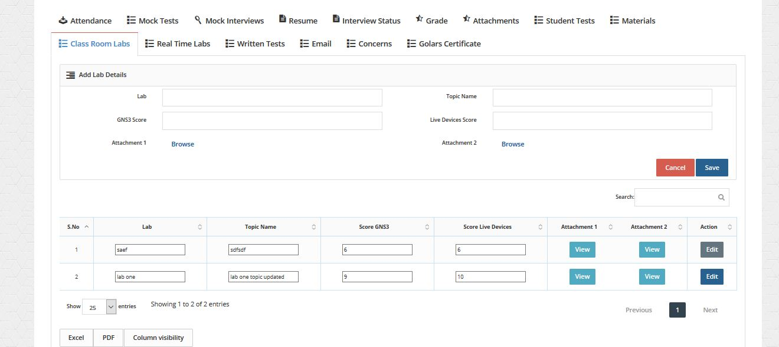

**8.8.12) Real-time Labs:**

* Counsellor add real-time labs to student, and see details of student c real-time, view real-time attachments.
* Click add new button for adding real-time labs of student, click cancel button to hide real-time labs form.

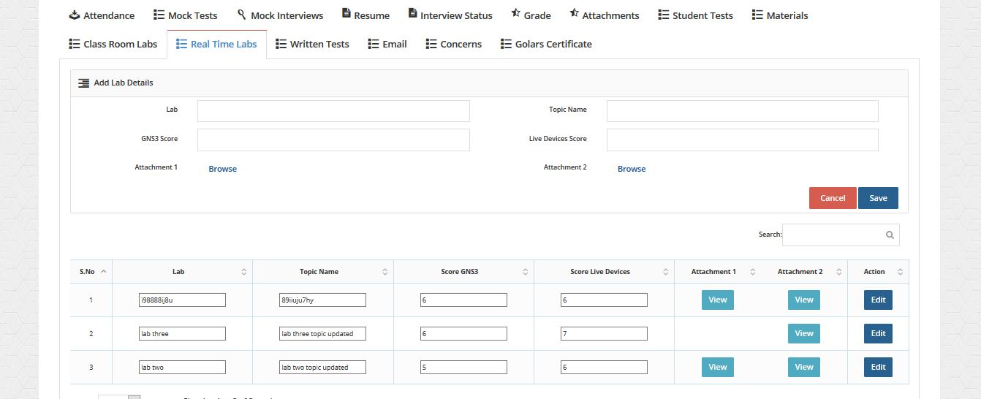

**8.8.13) Written Tests:**

* Counsellor see written tests and edit score.

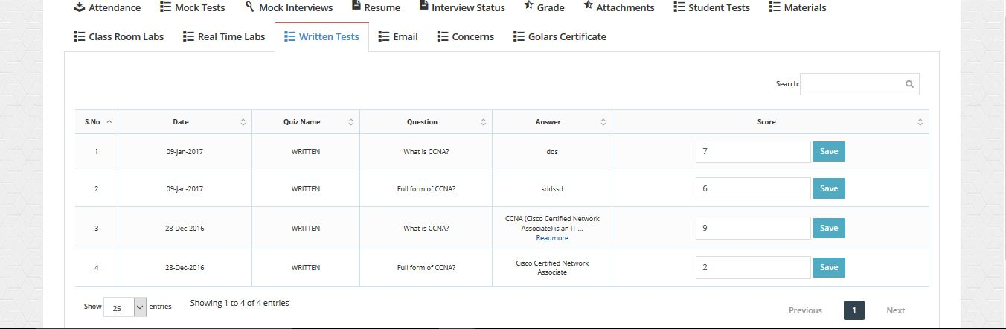

**8.8.14) Email:**

* Counsellor send an email to student.

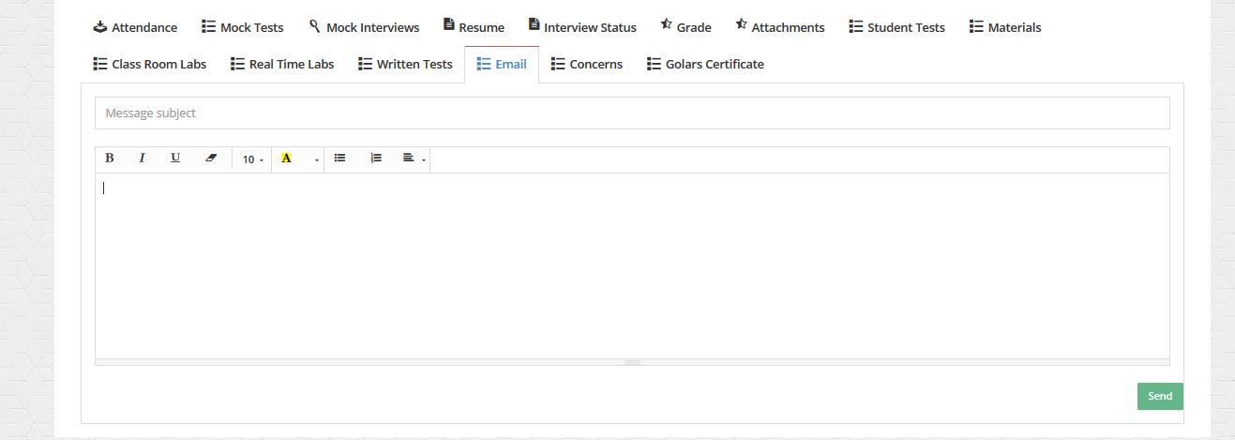

**8.8.15) Concerns:**

* Counsellor can add concerns to student.
* Click add new button for adding concerns of student, click cancel button to hide concerns form.

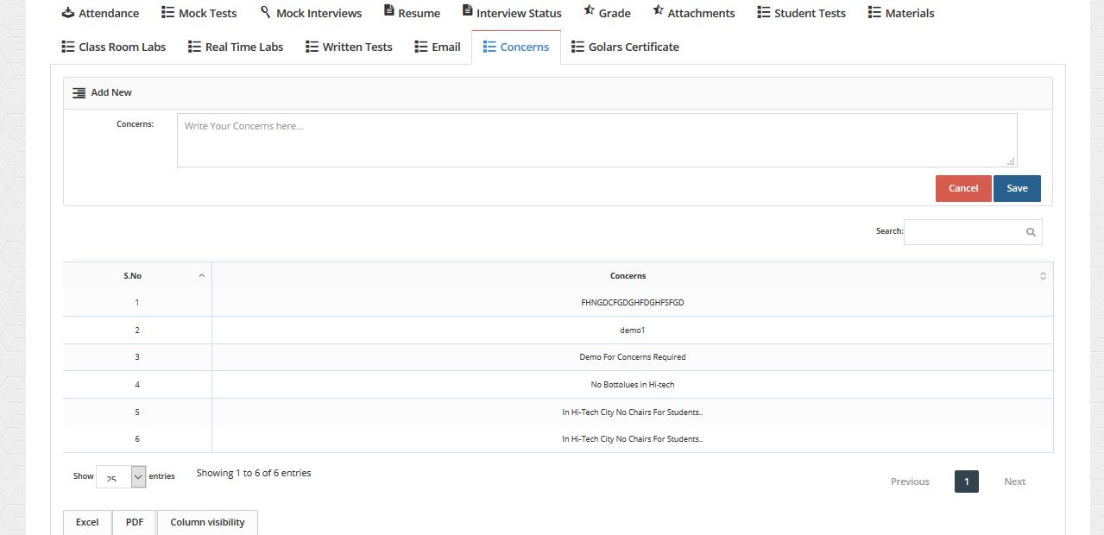

**8.8.16) Golars Certificate:**

* Counsellor can add Golars certificate to student.

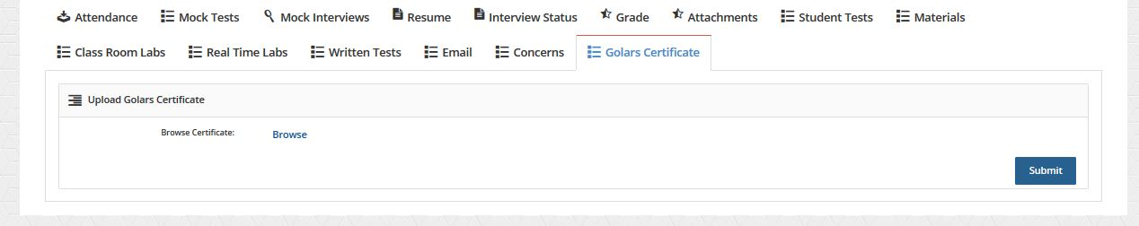

**8.8.17) Mock HR:**

* Counsellor can conduct Mock HR Exam to Students.

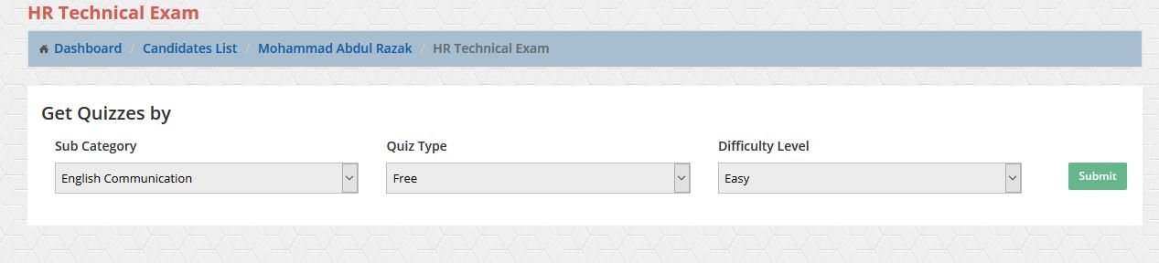

* Student select category, Quiz type, Difficulty Level and click Submit.

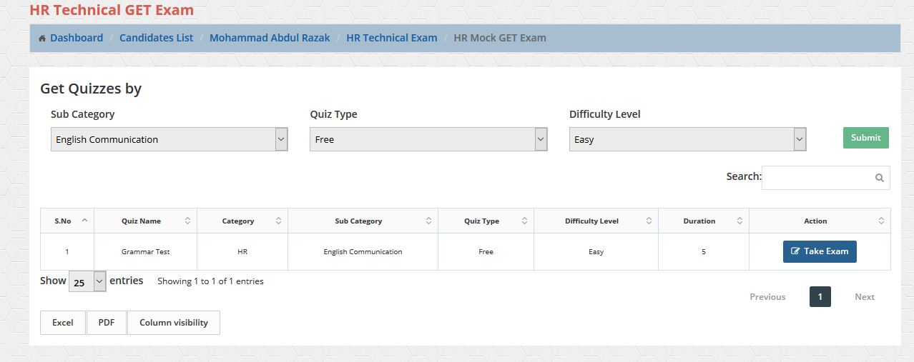

* Student Ready to Take Exam and click on it.

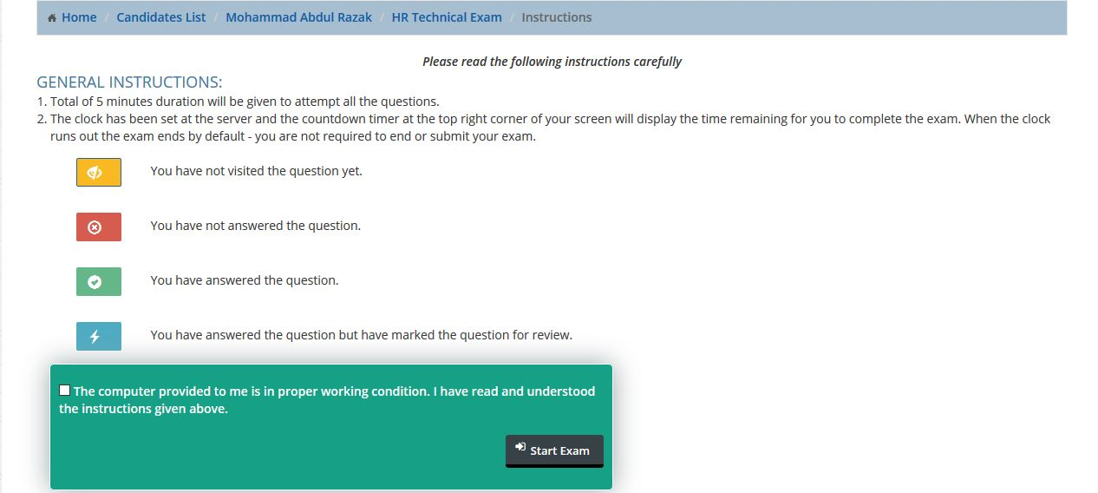

* Check the Check box and click start exam.

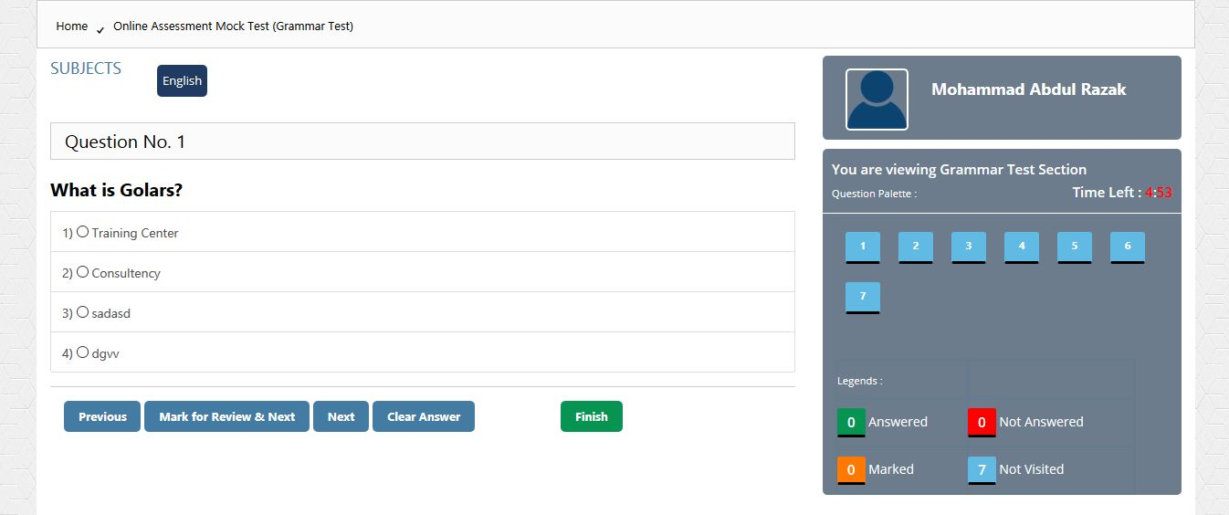

* Blue Color means not visited the question yet.
* Green Color means answered the question.
* Orange Color means answered the question but have marked the question for review.
* Red Color means not Answered.

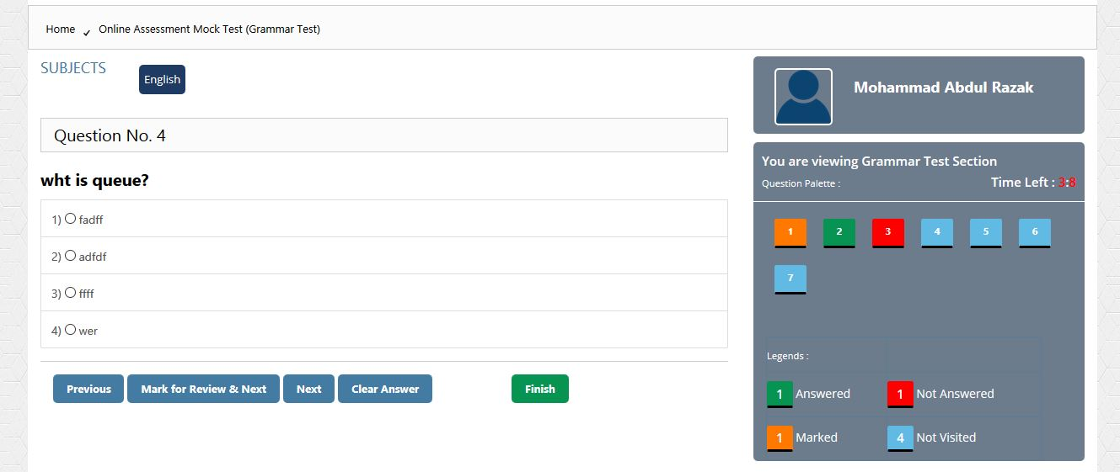

**8.8.18) Mock Technical:**

* Follow the Mock HR Instructions as shown in above.

**8.8.19) Client IQ:**

* Follow the Mock HR Instructions as shown in above.

**8.9) Aspirants:**

* Students is Ready to crack the interview. As displayed below.

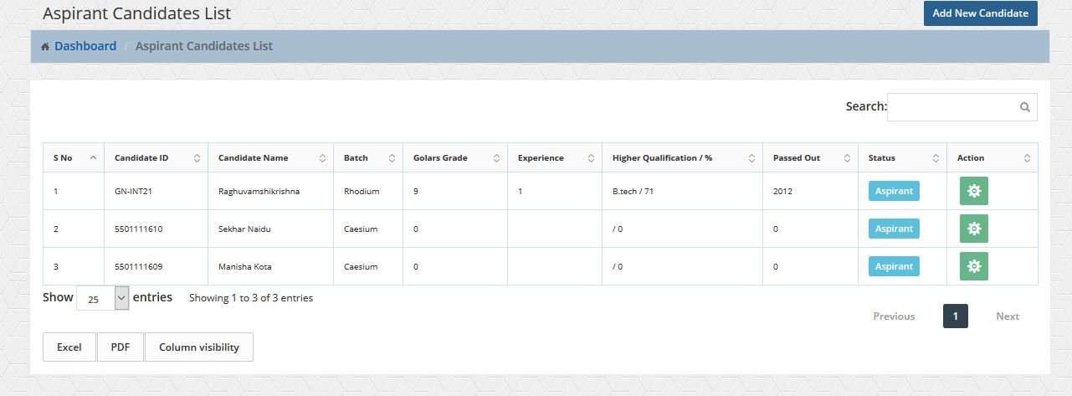

**8.10) In Training:**

* Students is in training course is still running. As displayed below.

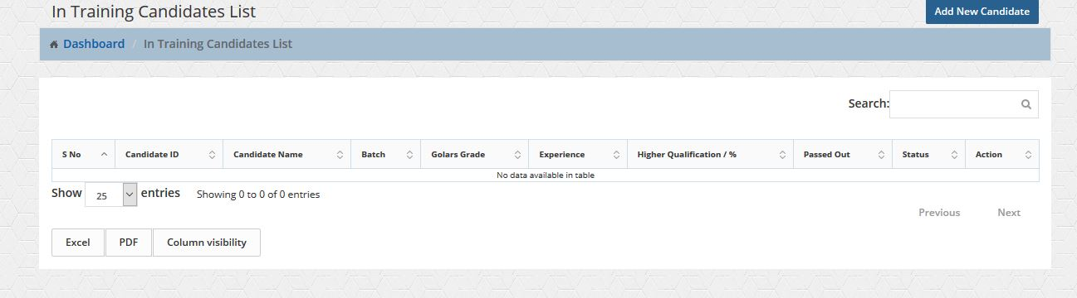

**8.11) Placed:**

* Students who are Successfully completed course and got a job. As displayed below.

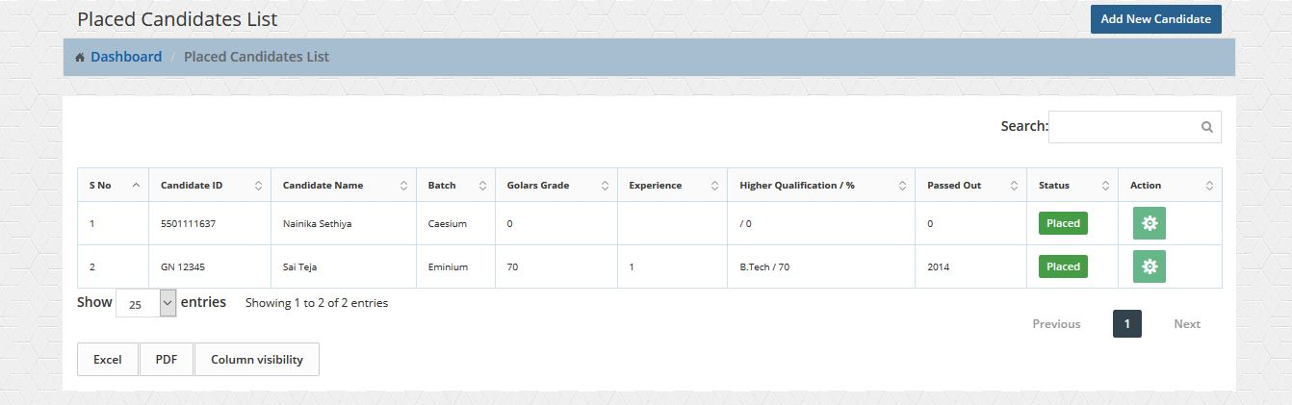

**8.12) Dropped:**

* Students who are left Course without completing. As displayed below.

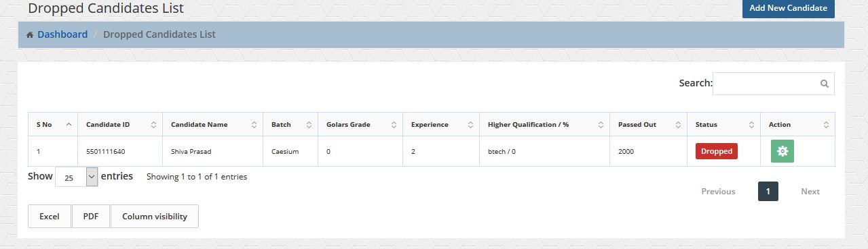

**8.13) Dropped Refund:**

* Students who are left Course without completing fee amount will be refunded back. As displayed below.

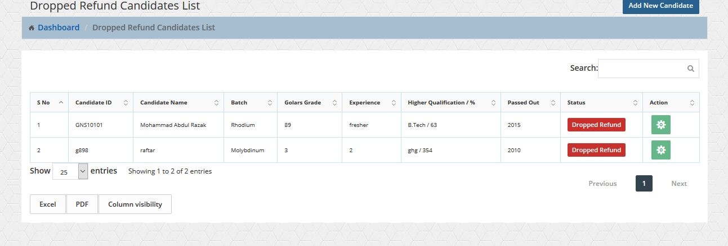

**8.14) Tickets:**

* Students can raise issues (any problem if he/her was facing with management or related with course) if the management solve that issues it will ‘pre-closed’, issues(problem) successfully will not going to be closed until the student have not closed.

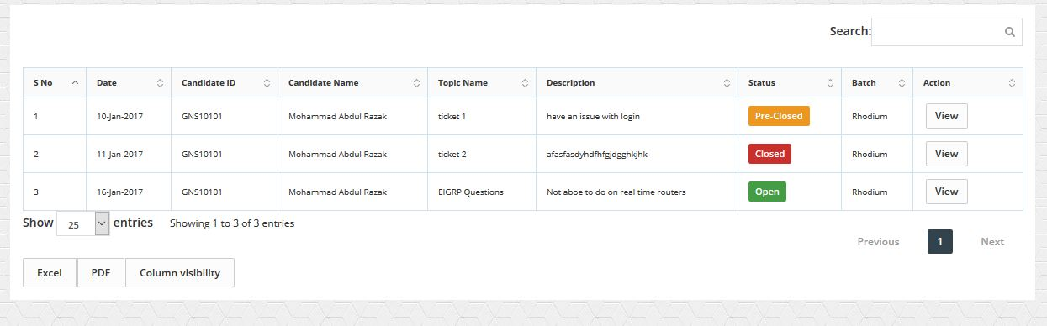

# **9. Student Module:**

**9.1) Home:**

* Student when he logged in. student can view his profile, Golars certificate, his course complete details, Attendance, Exam Results, Mock Tests, Resume, Mock interviews, interview status, Materials, Classroom labs and Grade.

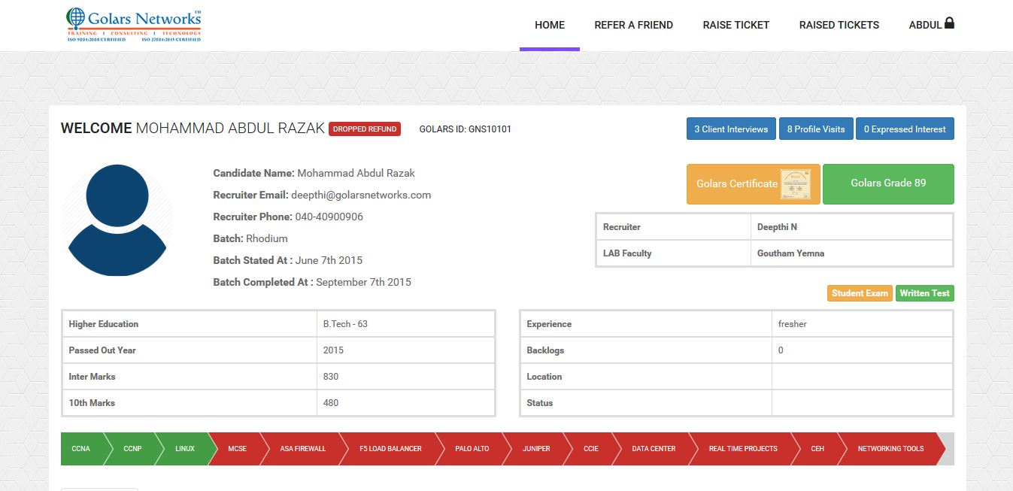

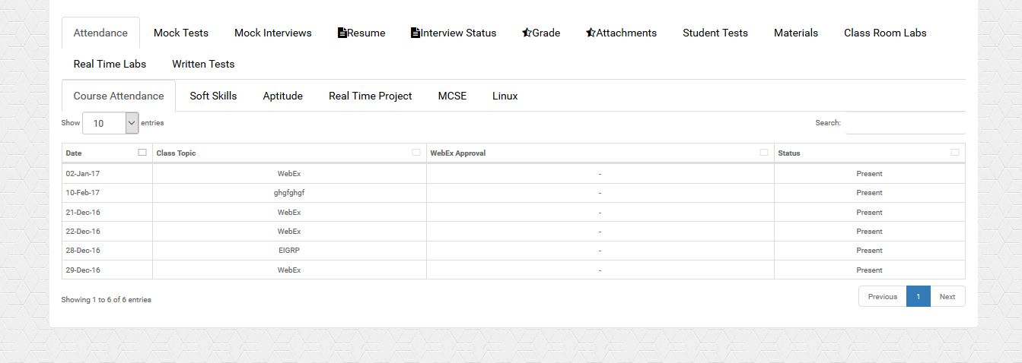

**9.2) Refer a Friend:**

* Student when he Refer a Friend. He needs to forward contact details to Counselor. As shown below.

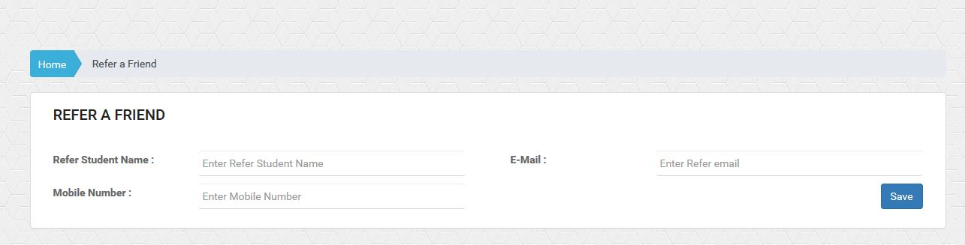

**9.3) Raise a Ticket:**

* Students can raise issues (any problem if he/her was facing with management or related with course) if the management solve that issues it will ‘pre-closed’, issues(problem) successfully will not going to be closed until the student have not closed.

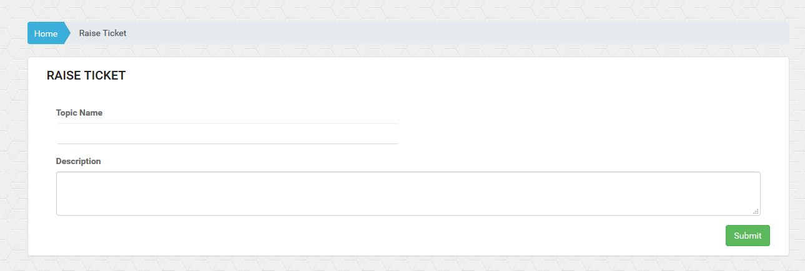

**9.4) Raised Ticket:**

* Students whatever raised tickets(issues) status will Displayed and even he can have closed that ticket(issues) if he feels satisfied with solutions. As shown below.

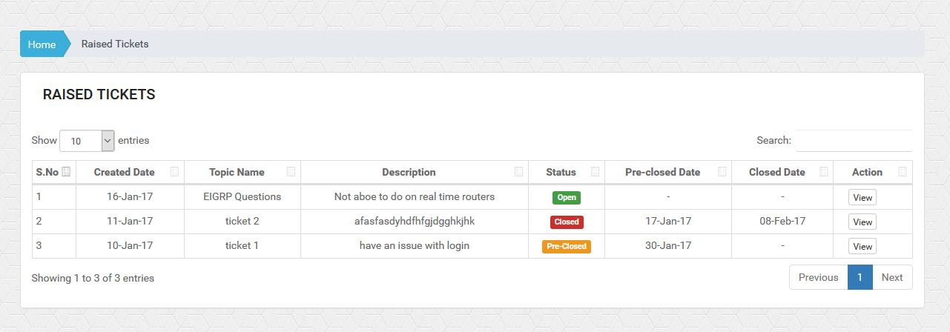

**9.5) Student Exam:**

* Students can write a mock Exam when he go for exam he needs to select Category, Quiz type and Difficulty Level. When he takes Exam As shown below.

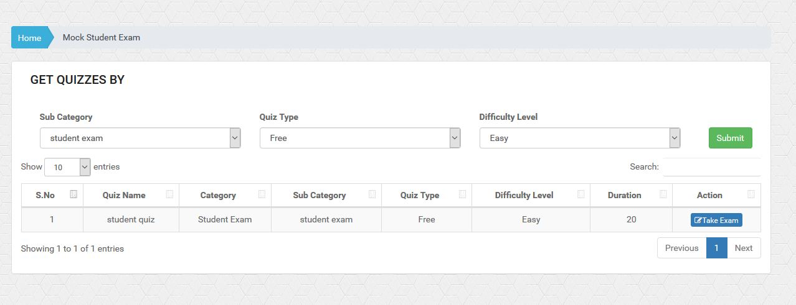

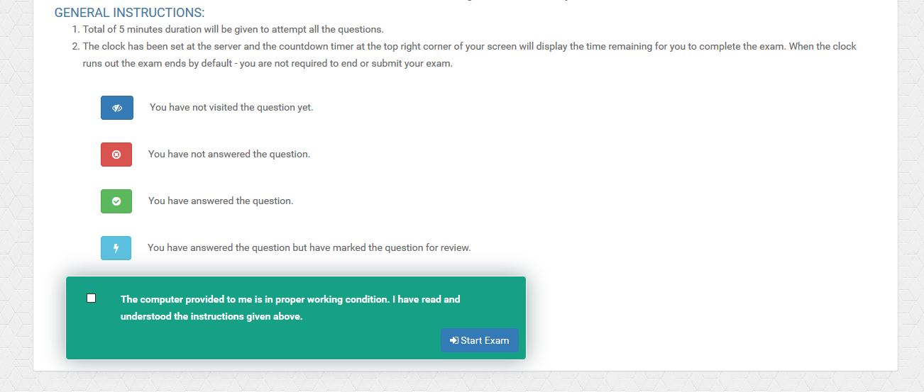

* Blue Color means not visited the question yet.
* Green Color means answered the question.
* Orange Color means answered the question but have marked the question for review.
* Red Color means not Answered.
* After Completion of exam click Finish Button Result Will Be Displayed.

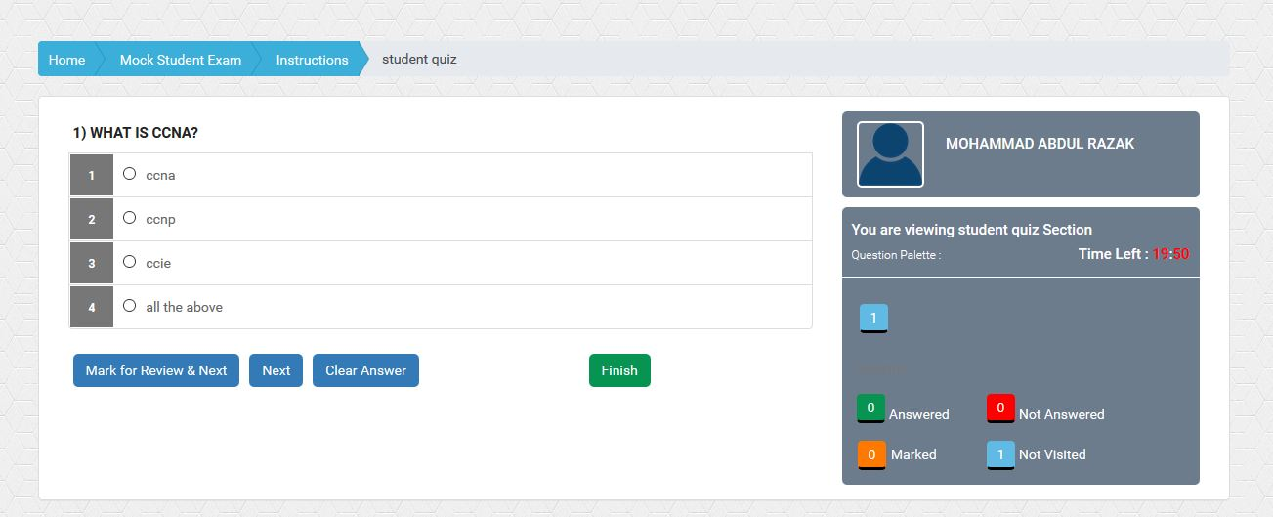

**9.6) Written Exam:**

* Follow the Student Exam Instructions as shown in above.

# **10. BDM Module:**

* BDM when he/her login BDM can add Clients. Schedule an interview with selected students, he can track the complete interview details from the Clients.
* BDM Team Can Edit Client Details.
* Schedule Interview To Students, Shared Profiles.

